We need you! Show your support for our residents/tenants, our staff and the State Budget!
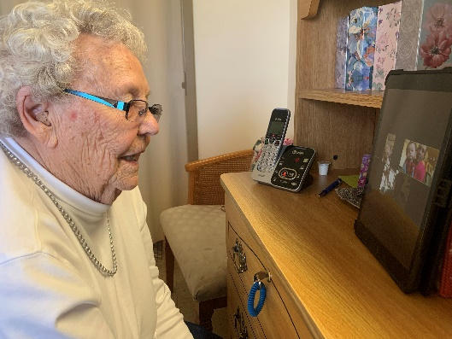
Our residents deserve the best care possible. Throughout the COVID-19 pandemic, our caregivers showed up for work each and every day to do their jobs while so many of us sheltered at home. They worked tirelessly and courageously to provide critically necessary care and service to older adults and persons with a disability.

The proposed 2021-23 State Budget includes $318 million to support our caregivers and our long-term care providers to ensure that they can keep on caring for our parents, grandparents, friends and loved ones.

Please take a moment to voice your support for what we are trying to accomplish. We plan to share your support with the Wisconsin Joint Finance Committee as they continue their work on the 2021-23 state budget. Thank you very much for your kind consideration of our request.
 | First Name | Last Name | Street Address | City | State | Zip Code
1
2
3
4
5
6
7
8
9
10

 | First Name | Last Name | Street Address | City | State | Zip Code
11
12
13
14
15
16
17
18
19
20
21
22
23
24
25
Voice your support for our residents, our staff and our facility!

 | First Name | Last Name | Street Address | City | State | Zip Code
26
27
28
29
30
31
32
33
34
35
36
37
38
39
40

 | First Name | Last Name | Street Address | City | State | Zip Code
41
42
43
44
45
46
47
48
49
50
51
52
53
54
55

 | First Name | Last Name | Street Address | City | State | Zip Code
56
57
58
59
60
61
62
63
64
65
66
67
68
69
70

 | First Name | Last Name | Street Address | City | State | Zip Code
71
72
73
74
75
76
77
78
79
80
81
82
83
84
85

 | First Name | Last Name | Street Address | City | State | Zip Code
86
87
88
89
90
91
92
93
94
95
96
97
98
99
100

Please attach additional signatory pages should others wish to demonstrate their support!

