

**LeadingAge Pathways:**

***A Framework for Addressing Americans’ Financial Risk for Long-Term Services and Supports***

***October, 2013***

***Final Report, pending LeadingAge Board Approval***

**LeadingAge Pathways: *A Framework for Addressing Americans’ Financial Risk for Long-Term Services and Supports***

**Introduction**

*“My husband and I were always savers, planning and stockpiling for the future as best we could. Who could have known he would get Alzheimer’s disease and need years of nursing home care costing $80,000 each year? Who can possibly be prepared for that?”* Elise, age 80, wife of 53 years to John who has Alzheimer’s disease and has lived in a skilled nursing facility for 11 years.

*“My wife and I tried to purchase long term care insurance when we were in our 40’s. I couldn’t get coverage due to a medical condition and the premiums for my wife’s coverage more than doubled in a ten year period. What are we supposed to do?”* Mark, age 69, long term care insurance consumer.

*“Isn’t there some kind of government program that pays for nursing home care when my parents or I need it? Haven’t we all paid ahead for that at work, you know, Medicare?”*  Joe, age 35.

One might read these statements and conclude that the issues raised are “not my problem.” But they are. The need for long-term care is a risk we all face, a highly probable risk. As we reach age 65, we have a 70% chance of needing long-term care, for an average of three years before death. [1] Because this need remains a risk and not a certainty, the inclination is to ignore it despite the odds. This approach has a high price tag for individuals and our country.

The need for long-term services and supports (LTSS)[2] and related caregiving has increased with the aging of the population, with its cost far surpassing the capacity of families to provide, depleting personal resources and outstripping public financial resources. Over 12 million adults in the U.S. currently need care; they are our neighbors, friends and family members.[3] Despite the temptation to ignore the problem, its consequences are becoming increasingly apparent at the personal, local, state and federal levels and the question for our country is, “What do we need to do NOW?”

LeadingAge—a community of over 6,000 not-for-profit organizations that promote services and programs that support older adults and those with special needs—set out to answer this question. LeadingAge convened a blue ribbon, multi-disciplinary task force and this report summarizes its work. The Task Force is not promoting a definitive answer. Rather, it offers paths to the answer, rooted in the conviction that addressing America’s LTSS needs must be a national priority. For this to happen, we must engage in a spirited yet respectful discussion of what we want to accomplish nationally, regionally and locally, the options for getting there, and how together we can drive toward needed change.

Through this report, LeadingAge is advancing this national discussion by modeling a process, uncovering important facts and perspectives, and laying out a full range of options that span private market, public and mixed solutions, along with their implications, for consideration as “America’s response” to the need. It builds upon and furthers the vision put forth by the Federal Commission on Long-Term Care, by suggesting various pathways for addressing Americans’ financial risk for LTSS. LeadingAge views the work of the Task Force as a necessary, yet insufficient, *first* phase. LeadingAge’s commitment is to undertake a second phase of work between now and mid-2015. Phase two will include community engagement and dialogue to refine the pathways and foster development of specific proposals, including actuarial and economic analysis, under one or more of the pathways. LeadingAge seeks to undertake this second phase in partnership with others who are also committed to identifying and implementing America’s response to the need.

**The Challenge**

*“My husband and I could never have known that he would get Lou Gehrig’s disease and certainly not in his 40’s when our children were young and we hadn’t had time to save much.”* Melissa, age 51.

*“Long term care insurance? Are you kidding? Have you seen how much it costs? I am just trying to put food on the table and make house payments. It is out of the question.”* Alex, age 41.

LTSS in the United States is an enormous proposition, currently costing about $363 billion annually—more than two percent of the nation’s GDP[4] —to provide for the needs of over 12 million people—almost equally split between adults who are age 65 and older (56 percent) and adults under 65 (44 percent)[5]. With the aging of the American population, **the costs of LTSS are expected to grow, doubling (in constant dollars) in little over ten years (2025) and multiplying five times by 2045.[6]**

[7]

Figure does not include LTSS that is not counted towards GDP, specifically, unpaid family caregiving valued at $450 billion annually

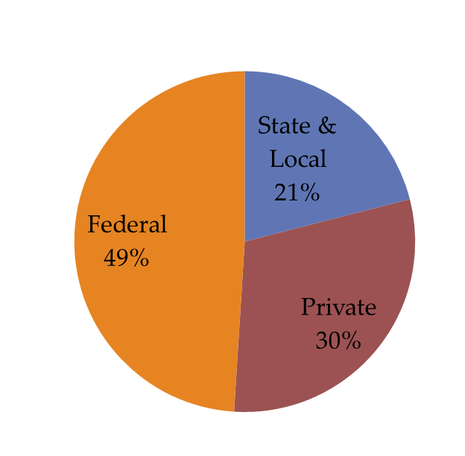 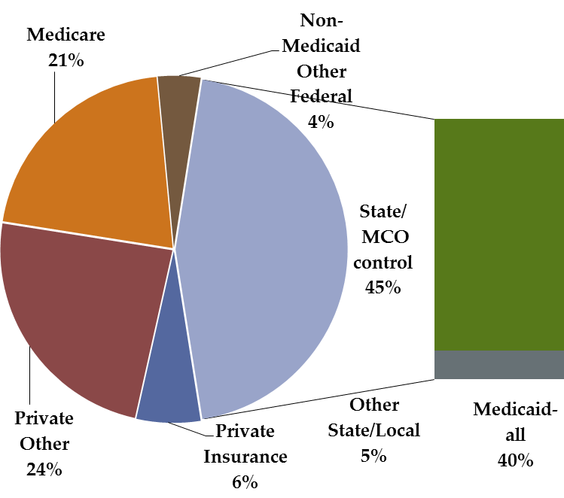

Funding sources by program

Funding sources

As people live longer and baby boomers age, the risk of needing LTSS will increase exponentially as the number of older Americans increases, both in numbers and as a percentage of the U.S. population. Today, more than 40 million people in the United States are 65 and older, a number expected to more than double by 2050. Within this group, the number of those 85 and older—who have the highest rates of disability and institutionalization is projected to rise rapidly over the next 40 years.[8] The number of Americans needing LTSS is expected to double over the next thirty years.

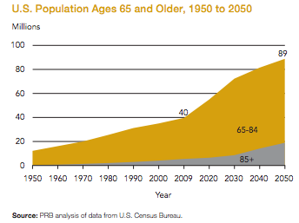

Every one of us faces a risk, but not a certainty, that we will need LTSS.[9] Nearly 70 percent of those who turned 65 in 2005 will use some long-term services from paid help or other caregivers, for an average of three years before death. Although about 30 percent will require no long-term services, 20 percent will need care for between two and five years, and another 20 percent will require this assistance for more than five years.[10] Paying for care is expensive.  Private-pay (i.e. not subsidized by public programs) national average rates for a nursing home private room were $90,520 annually in 2012; average private-pay rates for home health aides were $21per hour in 2012.[11] Despite these staggering numbers, our “system” of financing and providing care is cobbled together from an age when the need for LTSS was much less common. Neither family caregiving nor Medicaid, the two mainstays of LTSS, is equipped to handle future care needs.

Family members provide the majority of care for those needing LTSS. More than 42 million people provided unpaid care to an adult in 2009, with a value estimated at $450 billion.[12] Today, an estimated 17% of employed part-time or full-time adults care for a family member or friend.[13] Families continue to do all they can, often to find that that their own finances, health and employment security are stretched to the breaking point. For example, a national survey of adults 40 and older found that 44 percent of those surveyed are “a great deal” or “quite a bit’ worried about being able to pay for care or help they might need as they get older; another 27% are moderately concerned.[14]

When all else fails, people turn to Medicaid to finance their care, even though they must impoverish themselves to get this help. Medicaid, a program jointly funded by the federal and state governments, was designed as a “safety net” for the exceptional costs that could not be borne by individuals. Today, over 40% of LTSS expenditures are paid by Medicaid. The Congressional Budget Office estimates that spending on Medicaid will rise from nearly two percent of the U.S. GDP in 2013, to 3.2 percent in 2038, in part due to the aging of the population.[15] This has implications not only for federal but also state budgets. At the state level, where deficit spending is not allowed, Medicaid spending threatens to drive out other spending. In 2009, Medicaid surpassed K-12 as the largest single segment of state budgets; and as Medicaid continues to rise, the portion of spending devoted to K-12 is falling.[16] If trends continue, more than 35 percent of states’ budgets will be needed for Medicaid by 2030, of which half will be for LTSS.[17]

Another 21% of LTSS is paid by Medicare. Medicare and Medicaid are two of the largest drivers of federal budget deficits.[18] When all governmental sources are included, an estimated 70% of LTSS is paid by public sources. [19]

Due to the demographics and needs within our country, it is inevitable that LTSS costs will exist and must be borne one way or the other. The question for our country is who will bear the costs and how will they be borne to achieve the best outcomes and create the most sustainable and feasible financing for LTSS? In addressing these questions, inaction does not equate to “least expensive.” While measurements vary, a number of sources suggest that LTSS may be costing the American public the same or even more (in terms of public spending as a percent of GDP or on a per capita basis) than some countries with specific public financing approaches to LTSS, such as Japan or Germany.[20] Thus, there is ample room within the current system to deliver LTSS that is more effective, efficient and affordable.

All of this converges into a stark problem for Americans, stated simply by the Task Force:

*Our country and its people cannot meet their long-term service and support needs.*

**The Approach**

To address this problem in our country is an enormous undertaking, with abundant room for disagreement about outcomes and methods. LeadingAge sought a process to navigate the full range of views, values, and hopes around this issue in order to build momentum for needed change.

LeadingAge created a Finance Reform Task Force, an expert panel of 20 individuals from diverse disciplines and representing the full range of perspectives and values that are encountered on the topic of long-term care and its financing. The Task Force was charged with recommending a framework for action to help consumers and our country plan for the potential need for LTSS.A list of Task Force members is included at the end of this report.

Using principles from scenario planning, the Task Force developed seven possible pathways for financing LTSS. The Task Force reasoned that moving forward with multiple pathways would position our country to respond to future conditions that are unknowable at the present time. Depending on the circumstances, one path may be more effective and suitable than others. In studying experiences from other countries, the Task Force learned that national programs and policies continually adjust over time to meet needs as they evolve, and concluded that finding a policy entry point is critical for our country to move forward on this issue. To this end, it is best to be prepared with multiple pathways.

Below is a summary of the process and tools used by Task Force members; a review of their key findings; and an outline of the seven pathways they developed for consideration by policy-makers and the public. More detailed information on each can be found in the Report Appendix.

**The Solution Framework**

A national conversation about LTSS requires a framework for thinking about and discussing the challenges and potential solutions. We cannot design effective solutions if we do not know where we are headed and what contributes to the problem. To this end, the Task Force constructed a “solution framework” that sets forth a long term vision with shorter term goals that must be achieved to foster the vision:

***Vision:*** *Achieve societal and individual ability to prepare and pay for LTSS needs*. This vision must be achieved progressively, with shorter term goals accomplished successively over the next ten years.

***Shorter term goals:*** The Task Force recognized that achieving the vision requires the pursuit of several goals aimed at addressing multiple contributors to the overall LTSS problem.

1. ***Americans must have information and awareness about the need for LTSS and how to plan for those needs****.* The need to plan for LTSS is a relatively new phenomenon. Regardless of how our country proceeds with financing LTSS, the need for information and education is imperative.
2. ***Americans must have meaningful choices for meeting their LTSS needs.*** Americans need opportunities to act—options that are appropriate and can be tailored to care needs as well as varying financial and familial circumstances. Any variety of public and private mechanisms could be made available to the American public; seven possible approaches have been developed by the Task Force.
3. ***Available options must be feasible and sustainable financially and politically***. Our current approaches to LTSS are not sustainable. Any new solution must be sustainable for everyone involved, including those who pay for LTSS and those needing care. The solution must also have widespread political acceptance, ensure that professional caregivers are fairly compensated and recognize and support the critical role of family caregiving.
4. ***Our systems must be designed and aligned to foster quality and cost-effective care.*** The bottom line is quality care for Americans. Any financing approach must ensure that Americans can get the care they need at prices they can afford, and that the system encourages care that is effective and delivered efficiently. This includes improving the integration of acute care and LTSS, better using technology, and helping people living better in their homes, which is where most people want to be as they age.
5. Meaningful Options on which People Act
6. Information/ Awareness Regarding LTSS

**VISION**:

Achieve Societal and Individual Ability to Prepare for and Meet LTSS Needs

1. Systems that Foster Quality and Cost-Effective Care
2. Feasibility/Sustainability of Options including, financial, political, labor (paid and volunteer)

**Pathways Toward Change**

With the solution framework in hand, the Task Force developed a set of pathways to address the LTSS problem. As an aid in doing this, a decision matrix identified many of the myriad questions that would need to be addressed in designing any given solution. This matrix was hierarchical, beginning with high level questions such as: “Do we want our solution to address only elderly adults, or all people needing LTSS?” and “What role should the government play?” The questions progressively became more narrow, addressing issues such as the role of employers, and whether there would be tax incentives to promote purchase of insurance and/or savings. This process helped ensure that a wide variety of pathways were being considered, and that the various pathways were internally consistent.

The Task Force identified seven pathways that run a spectrum of options, spanning from highly reliant on private markets to highly reliant on a public programs. The Task Force included a status quo pathway, for while status quo situations might not require action, implications and outcomes unfold nevertheless, and the Task Force concluded that these should be understood just as fully as any of the other pathways. It then considered the potential implications of the pathways for people who need care, the market, caregivers, state and federal budgets and likelihood of acceptance given U.S. history, culture and the current environment.

The seven pathways are:

1. Status Quo
2. Personal Responsibility
3. Private Market
4. Private Catastrophic
5. Public Catastrophic
6. Common Good
7. Comprehensive

A brief description of each pathway follows with a fuller description provided in the Report Appendix. While no pathway is perfect, many reflect positive steps forward; thus, the descriptions attempt to identify some of the opportunities and challenges that exist within each pathway.

**1. Status Quo.** In the United States, there is an expectation that people will take personal responsibility for their LTSS. The U.S. operates a “safety net” system that is heavily reliant on Medicaid for those who are impoverished. However, over 40% of LTSS expenditures are born by Medicaid, with an additional 21% paid by Medicare and 9% by other public sources, meaning that 70% of spending for LTSS is publicly financed.[21] Medicaid and Medicare are already under considerable fiscal stress, a situation that will be exacerbated with the coming boom in our aging population. The status quo is not fiscally sustainable for Medicaid and Medicare, as neither is structured to meet the impending demand for LTSS.

In addition to the publicly-financed programs, some individuals have elected to purchase long term care insurance products, which are regulated by state and federal governments. Take up of private long-term care insurance has been limited; roughly 10% of Americans aged 65 and older have purchased such an insurance policy, a smaller percentage than Germany, France or Israel, which have public LTSS systems. [22], Private insurance covers about 6% of annual LTSS expenditures.[23]

**2. Personal Responsibility.** This pathway aims to reduce the government role in financing LTSS by tightening the public safety net and narrowing eligibility, with the intention of inducing more personal responsibility in planning for and meeting individual LTSS needs. Individuals may seek insurance coverage for LTSS in the private market. The government would offer no incentives or subsidies for the purchase of long-term care insurance; however it would provide preferential tax treatment for those who save for their long-term care needs. Under this option, compared to the status quo, the public safety net would shrink slightly as a percentage of total long-term care costs, as would the number of people potentially covered and the number who receive benefits. The challenge to address with this pathway is that there would likely be an increase in unmet needs because fewer people will be eligible for Medicaid and there would not be new or more affordable options for them in the private market.

**3. Private Market**. This pathway seeks to activate and strengthen the private market as the primary source of meeting Americans’ LTSS needs. It would encourage the development of a greater choice and standardization of products, including those that offer cash benefits, as well as incenting the purchase of those products. Cash benefits would not only provide policy holders with more flexibility to customize their services, they also are actuarially more predictable for insurers. Incentives might include preferential tax treatments, subsidies based on income, and government sponsored stop loss coverage or reinsurance pools to limit the cost of insurance products and to encourage more private providers to enter the marketplace by reducing their risk. LTSS planning, education, counseling and purchase of private products would also be available through employers and health exchanges. Compared to the status quo, an uptick in private coverage would be expected, with a corresponding reduction in reliance on the safety net. The challenge to address with this pathway is that the increased uptake would likely be limited; analysts estimate that uptake might increase from 10% to 20%.[24] Thus, this option would provide limited relief for state and federal Medicaid budgets and would only slightly reduce the number of Americans who are unprepared the cost of LTSS.

**4. Private Catastrophic.** With this pathway, the government would require individuals to purchase catastrophic long-term care insurance made available in the private market (although persons who could demonstrate the means to cover their own expenses would be allowed to opt out). Catastrophic coverage would be triggered when a covered individual meets a LTSS qualified expense threshold and a functional need level. Benefits could be in the form of services or cash. Qualified expenses could include family caregiving costs and benefits, to acknowledge the role of family caregiving and support individuals in the context of family and community. The objectives of this scenario would be to avoid the impoverishment that occurs when long-term care expenses mount, to acknowledge the important role of families in providing care, and to ease pressures on state and federal budgets by substantially reducing the reliance on the Medicaid safety net. This type of coverage might prove far more affordable than existing products and has not yet emerged in today’s marketplace.[25]

Government would have a number of roles in this pathway. It would establish the standards for “qualified” private market insurance products that offer basic, affordable catastrophic coverage. These could be marketed in a number of ways, including through employers and health exchanges. Government would also provide stop loss coverage for qualified plans to help make insurance more affordable for Americans, and to encourage a competitive marketplace for such products. Government would provide subsidies to Americans who are unable to afford private insurance. The safety net would no longer be needed as currently constructed; instead it would become an alternative insurance pool for high-risk individuals who are unable to secure coverage in the private market. Compared to the status quo, safety net expenses would be considerably reduced (depending on the successful enforcement of the purchase requirement), thereby reducing pressure on state and federal Medicaid budgets. Additionally, most Americans would be covered against large-scale LTSS expenses. While this pathway offers potential for addressing the LTSS problem, the challenge will be political acceptance: a national survey of adults 40 and older found that 42 percent of Americans oppose a requirement that individuals buy private long-term care insurance.[26]

**5. Public Catastrophic.** This pathway is similar to the previous scenario, except that the insurance coverage would be provided through a public program and Americans would be required to purchase long term care coverage by paying premiums to the government. A public program holds more opportunity to be shaped by policy-makers to meet agreed-upon public objectives, such as eligibility and the basis for pricing premiums. Because the insurance pool is inclusive of all Americans, this scenario effectively would become the public safety net, replacing the need for Medicaid for most Americans. Once again, benefits would come in the form of services and/or cash. Persons with lower incomes might still rely on the safety net to the extent they could not afford care at expenditure levels below the catastrophic coverage level. Additionally, Americans could still choose to cover their front-end needs with private insurance. Compared to the status quo, safety net expenses would be reduced dramatically and Americans would be covered against large-scale LTSS expenses. While this pathway offers the potential for addressing the LTSS problem, the requirement of participation could be a challenge.

**6. Common Good.** This pathway would create a public program to meet basic, “front-end” LTSS needs for working and retired Americans, by providing cash and/or services for a defined dollar or time limit. Underpinning this pathway is the view that long-term care is a risk common to all Americans, a risk most effectively and fairly handled by pooling that risk (such as unemployment insurance for joblessness or longevity via Social Security). Participation would be either required or strongly incentivized and premiums would be based partially on income. Because coverage would not be comprehensive, the safety net remains for people who have not met minimum contribution requirements, are outside the program, or are unable to afford LTSS expenditures that exceed those covered by the program. The private sector would be encouraged to develop supplemental and catastrophic need products, a market segment that has proven relatively successful in other countries (e.g., France, Germany and Israel).[27] Compared to the status quo, the safety net shrinks substantially and virtually all Americans would be covered in a way that supports individuals in the context of family and community. While this pathway would reduce pressure on state and federal Medicaid budgets and cover most people in need, its mandatory nature and departure from our current heritage of self-reliance will present challenges to adoption. However, survey data of Americans 40 and older suggest openness to such an approach, with 66 percent strongly or somewhat favoring a government-administered long-term care insurance program similar to Medicare.[28]

**7. Comprehensive.** This pathway combines the public catastrophic coverage and the front-end common good coverage to create a comprehensive program for LTSS needs providing a benefit of cash and/or services. Personal responsibility would come in the form of co-payments or deductibles—a feature of most long-term care systems that exist in the world today. Participation would be mandatory, nearly eliminating the safety net, which would remain only for those who cannot afford their share of co-pays/deductibles or who remain outside the system for a variety of reasons. While this pathway would reduce pressure on state and federal Medicaid budgets and cover the most people in need, it would be a radical departure from our current heritage of self-reliance and responsibility.

***Guiding principles****.* While the Task Force is not recommending one particular pathway, in deference to the national discussion it believes must take place, it has developed a set of principles through which the pathways can be evaluated and reshaped as needed.

* **Insurance for LTSS is essential.** The need for LTSS is a risk, not a certainty for any one person, but resources applied early on can and should help the large number of people who cannot afford to do more on their own; costs can be catastrophic for the unlucky. Thus, as is now and should be the consensus on which we build: insurance that broadly spreads risks must be available and affordable for all.
* **Fiscal responsibility and stewardship of public and private resources are widely-shared American values and critical for sustainable insurance reform**. Actuarially sound methods that build reserves over time sufficient to pay for future needs can and should reduce cost-shifts from current to future generations, taking into account the substantial intergenerational help (in both directions) that rightfully occurs. Methods such as combining annuities with LTSS insurance appear promising.
* **Public and private insurance have important complementary roles.** Meaningful insurance alternatives to Medicaid must be widely affordable and accessible as essential safety nets are preserved and strengthened. Private options can and should help meet the needs of more people, may benefit from publicly-facilitated market reforms, but should not cost taxpayers more than public options. Experience from other countries suggests that private markets are strengthened and public safety nets are preserved when public and private roles are clearly delineated.
* **Service delivery and payment models must be designed and aligned to foster person-centered, cost effective, high quality care.**  LTSS should be seamlessly integrated with acute, ambulatory, and other system components. Consumer choice and control must be ensured, and meaningful opportunities to participate in mainstream American life supported. Payment incentives must align, focus spending on critical direct care workers, and provide needed resources for family caregivers.
* **Affordable housing with services, facilitated by new technologies, is a key part of the solution.** Our country can and must implement sustainable strategies to increase the supply of affordable housing and connect that housing to needed services. Accessible, affordable housing and adequate services and supports are necessary for people to remain in their communities, and are an investment that results in both lower care costs and better quality of life outcomes. Services provided in supportive housing –such as meals, transportation to a doctor, health and wellness nurses and assistive technology –can help people stay healthier, remain independent longer, and avoid moving to more expensive settings, such as nursing homes or hospitals.

**Toward a National Discussion**

A short-term goal of the Task Force is to spearhead a national discussion as a necessary precursor to implementing a new LTSS solution for our country. The Task Force recognizes that each of the seven pathways is rooted in different values and different viewpoints about the nature of our LTSS problem and the most effective way to address that problem. These values and viewpoints are precisely what we must discuss to determine which pathways warrant further study. Critical questions in this discussion include:

* How do we help the most people within the fiscal constraints of state and federal budgets?
* Should we seek to guide LTSS (public) spending, such as a certain percentage of GDP growth or per capita amount, thereby establishing economic parameters within which we must work?
* How can a financing system help Americans needing LTSS maintain their independence to the maximum extent possible, and support their lifestyle choices, such as remaining at home and/or in the community?
* How do we move away from a system that requires impoverishment in order to access needed LTSS?
* Is there consensus for fostering dignity in aging by framing LTSS as a risk common to all Americans, rather than a personal risk in which individuals and their families are solely responsible?
* If LTSS is a common risk, what are the most cost-effective methods of pooling that risk?

In addition to answering these values-based questions, we must also address a set of technical questions relating to specific proposals that emerge under each pathway, including the economic and actuarial aspects of such proposals. Critical questions in this discussion include:

* What happens to overall spending on LTSS?
* What happens to public spending on LTSS?
* Who will bear the costs and how will those costs be borne?
* What is the impact on the federal and state budgets?
* At what price is any proposal actuarial sound and sustainable and is it affordable for Americans?
* Who will actually participate and to what benefit?

***Findings from other countries****.* To assist the discussion, the Task Force has compiled lessons from other countries. Our country is not the first to find its long-term care needs growing at unprecedented rates. Many other countries, especially aging countries in Western Europe and Asia, have developed national systems of addressing long-term care needs. The Task Force reviewed the experience of these countries and compared these experiences to those in the United States. [29] The Task Force was not seeking to import a solution, but rather to identify whether the experiences of those who have been grappling with LTSS for a longer time might provide any lessons for the United States as we move forward in defining a uniquely American solution. Some of the lessons were surprising.

* **Even though the U.S. does not have a “system,” we spend comparable public amounts to some countries that do have LTSS systems.** In the United States, the expectation is that people will plan and financially provide for their own LTSS, accessing the safety net only in dire circumstances. In fact, public programs bear nearly 70% of total spending for LTSS—comparable public spending on a GDP or per capita basis than some countries that have implemented broad public programs to address their long-term care needs.
* **There are many possible approaches with no “right” answer.** There are as many answers to addressing LTSS as there are countries. Across Western Europe, for example, each country has developed a system unique to itself, with a variety of service and financing arrangements, and differing mixes of public-private responsibilities and roles. No country has discovered a perfect solution or is without continued problems to solve.
* **Systems do not stop evolving once established; identifying a starting point is key.** LTSS systems are complex with many moving parts, such as reliance on and cultural attitudes towards family caregiving, demographics of aging, payment systems that incent families as well as providers, the maturity of private markets for insurance, institutional and home care, and inter-related public budget systems—where a change in one (e.g., Medicare) can yield unintended changes in another (e.g., Medicaid). Many countries have found that LTSS systems do not always materialize as envisioned when they were initially designed. Waiting for the “perfect” design is tantamount to inaction. These countries found the key is to begin with an initial approach, allowing experience and learning to guide future refinements and improvements. It has been an incremental process.
* **Once established, budgetary pressures and demands for expansion of benefits are common; however, these can be managed with program design.** Many countries found higher than expected demand for LTSS. Our country should be prepared for this, but realize that costs can be carefully managed through design of the program.
* **Policy innovation in LTSS is shaped by cultural values and expectations.** The experience from other countries suggests that innovation, and the goals for that innovation, are often shaped by cultural goals and values. For example, Japan wanted to remove a cultural expectation that daughters-in-law serve as caregivers. Germany sought the opposite, to recognize and support the care provided by family caregivers. And in Sweden, the cultural expectation is that the state provides care, whether childcare or long-term care.[30] The question for Americans as we consider the seven pathways is, what values do we want to support?
* **Policy innovation is shaped by policy heritage.** Few countries developed a system from a clean slate. Instead, countries tend to follow what is known as “path dependency,” that is, new systems follow on the path of existing systems. What path are we on in the United States? We begin with a strong expectation of personal responsibility, including a pride in self-reliance. If and when that fails, we shift to our safety net heritage, an approach that views the need for LTSS as a dependency, in response to which our country offers social assistance after all other resources have been exhausted and an individual is impoverished. Population demographics and labor force participation rates foretell an erosion of family caregiving, coupled with an emerging care culture of self-determination and autonomy, all of which will challenge our current paradigm. Public expenditures for LTSS are beginning to show strain, pressuring federal and state budgets alike. The question is whether we will view LTTS as a personal risk or view it as a common risk, warranting a shared response.

**Next Steps**

LeadingAge is pursuing a vision to progressively achieve societal and individual preparation for meeting LTSS needs. This vision can best be achieved by first pursuing shorter-term goals of substantially increasing awareness of and a sense of urgency around LTSS needs, and creating a movement to address the LTSS problem.

The Task Force acknowledges and commends the Federal Commission on Long-Term Care for beginning this nationwide conversation via its Final Report and Dissenter’s Report.[31] The Task Force affirms the recommendation to create a National Advisory Committee and pledges its support to ensure that any future Advisory Committee receives the reinforcement and momentum needed to foster new and effective approaches to meeting LTSS needs. Having built on the Commission’s work by outlining seven pathways, LeadingAge will pursue strategies to create mutually reinforcing activities that drive toward a national consensus on meeting our country’s LTSS needs.

LeadingAge views the work of the Task Force as a necessary, yet insufficient, first phase. LeadingAge’s commitment is to undertake a second phase of work between now and mid-2015. Beginning in 2014, LeadingAge will engage partners and other stakeholders in a national discussion that drives toward specific solutions. Phase two will include community engagement and dialogue to refine the pathways and foster development of specific proposals, including actuarial and economic analysis, under one or more of the pathways.

In phase two, LeadingAge will apply established community engagement methodologies and tools to build local, state and national coalitions. The coalitions will undertake community conversations that bring new sensitivities to LTSS in a way that promotes public understanding and facilitates exploration of and ultimately progress toward plausible solutions. LeadingAge will provide organizational support and assistance to coalitions undertaking these conversations, yet will not prejudge or advocate for particular solutions. While LeadingAge acknowledges that its guiding principles may influence and even re-shape some pathways, we are not prejudging which solutions our country might pursue. Instead we are interested in fostering an open-minded process that is inclusive of all viewpoints. And it is only fitting, because the risk of needing LTSS is independent of one’s political viewpoint. We’re all in this together with a shared imperative to find solutions.

In addition, LeadingAge will support the financial and fiscal analyses required to moving the national discussion forward. The status quo pathway is likely to be very expensive, and appears not be sustainable without major tax increases at the state and federal levels to support rising Medicaid expenses. It will be equally important to have clarity around the financial future under various pathways, ascertaining to what extent the solutions are affordable for Americans, both individually and as part of the public purse.

LeadingAge will undertake these strategies to achieve tangible movement towards solutions that impact all aspects of the LTSS problem. Options and strategies will be identified that will help achieve the vision of societal and individual ability to meet LTSS needs, through greater awareness of the size and scope of the issue, and how to address it through new options and systems that are affordable for payers, including individuals and governments, and that foster quality and cost-effective care. Example initiatives that might flow from the solution framework could include:

**Meaningful Options**

* New private insurance options, reforms, standards and innovations, e.g. disability/LTC conversion policy
* Incentives for LTC purchase or savings
* Public front-end or catastrophic program, e.g. medigap LTC policy or Medicare Part A LTSS inclusion
* Home equity LTCC financing options

**LTSS Information/ Awareness**

* Own Your Own Future Campaign
* Employer-based education and counseling campaign
* LTC counseling and product offerings through Exchanges

**VISION**:

**Achieve Societal and Individual Ability to Prepare for and Meet LTSS Needs over the Next 10 Years, Progressively**

**Feasibility and Sustainability of Options**

* Budget and design alignment
* Governmental stop loss pools
* Workforce initiatives re: enhanced training, wages and career ladders
* Caregiver support centers
* Rebalance towards HCBS

**Systems that Foster Quality and Cost-Effective Care**

* Integrated funding and delivery of health and LTSS
* Remove regulatory barriers to integration (e.g., 3-day qualifying stay and homebound reqs.)
* Value-based provider incentives
* EMR interoperability demonstrations

**Conclusion**

Every American faces a significant risk of needing LTSS and each of us faces a risk that the cost of LTSS could be financially catastrophic. We are not equipped to adequately protect against the risk, as individuals or as a nation. When faced with other risks of this magnitude, the U.S. has responded by pooling the risk and sharing in the costs, such as unemployment insurance and Social Security. With respect to LTSS, we must ask ourselves whether we want to create a shared solution to this most human of problems. LeadingAge and the Task Force believe the answer to this can be nothing other than a resounding “Yes.” We must work together to achieve a solution to how LTSS is delivered and paid for when it is needed. We invite you to work with us to identify a uniquely American response to the challenge of addressing our shared risk of needing and financing long-term care.

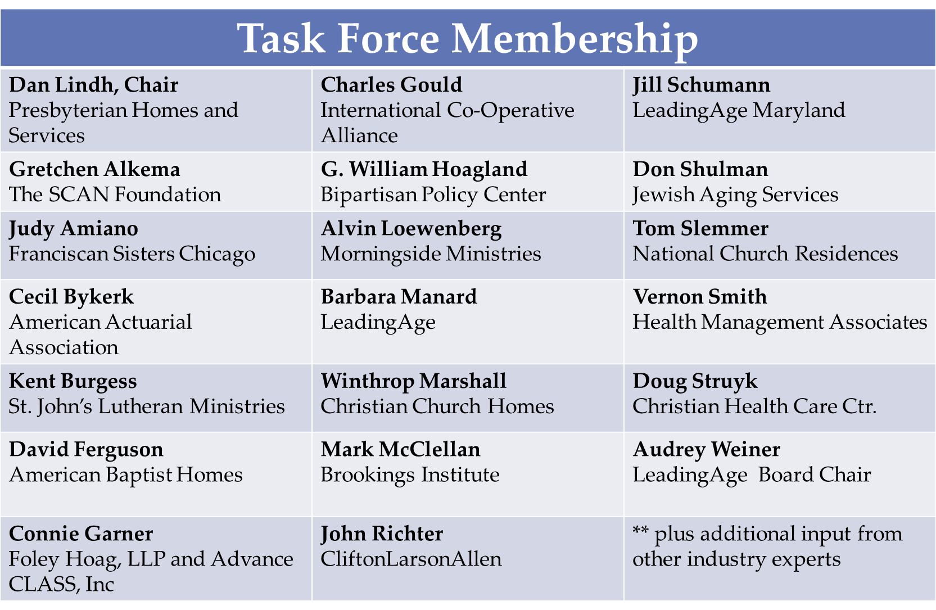

*Lead consultant: Olivia Mastry, Collective Action Lab

1. **ENDNOTES:**

   Peter Kemper, Harriet Komisar, and Lisa Alecxih, “Long-Term Care Over and Uncertain Future: What Can Future Retirees Expect?” *Inquiry*, 42, No. 2 (Winter 2005/2006): 335-350. U.S. Department of Health & Human Services. National Clearinghouse for Long-Term Care Information.http://www.longtermcare.gov/LTC/Main_Site/index.aspx. The SCAN Foundation. Who Needs and Who Uses Long-Term Care? 2012; http://www.thescanfoundation.org/who-needs-and-who-uses-long-term-care.
2. LTSS and long-term care are used interchangeably in this report. LTSS needs require assistance with activities of daily living (ADLS), such as bathing, dressing, eating, transferring, walking; and instrumental activities of daily living (IADLS), such as meal preparation, money management, house cleaning, medication management, transportation, to people who cannot perform these activities on their own due to a physical, cognitive, developmental or chronic health condition that is expected to continue for an extended period of time, typically 90 days or more. See, S. Katz, et. al. Progress in the development of the index of ADL. *Gerontologist,* 10:20-30, 1970; M. Lawton and E. Brody. Assessment of older people: Self maintaining and instrumental activities of daily living. *Gerontologist*, 9: 179-186, 1969.
3. Long term care in the United States is needed by 10.9 million community residents, half of them non-elderly, and 1.8 million nursing home residents, predominantly elderly.” H. Stephen Kaye, Charlene Harrinson and Mitchell P. LaPlante, “Long-Term Care: Who Gets It, Who Provides It, Who Pays and How Much?” HealthAffairs, 29, no.1 (2010).
4. Manard, B., Analysis of data in National Health Expenditures (2011); U.S. Census Bureau 2007 Economic Census; and National Health Expenditure Accounts Methodology Paper, 2011.
5. H. Stephen Kaye, Charlene Harrinson and Mitchell P. LaPlante, “Long-Term Care: Who Gets It, Who Provides It, Who Pays and How Much?” HealthAffairs, 29, no.1 (2010).
6. LeadingAge, “Financing LongTerm Care: A Framework for *America”,* 2006 citing projections done in 2004 using the Lewin LTC simulation model.
7. Manard, B., Analysis of data in National Health Expenditures (2011); U.S. Census Bureau 2007 Economic Census; and National Health Expenditure Accounts Methodology Paper, 2011.
8. Jacobsen et al., “America’s Aging Population,” Population Bulletin No. 66, No. 1. Population Reference Bureau, February 2011.
9. For people of all ages, the risk of needing extensive long-term care is uncertain, the costs of such care—in dollars and family caregiving—can be catastrophic, and the availability and quality of care may fall unacceptably short. Instead of the insurance protection we rely upon to spread the cost of other risks and assure access to needed service, when it comes to long-term care, costs are concentrated on the individuals and families of those who use service, backed only by a public program of ‘last resort.’” J.Feder, H.Komisar and R. Friedland, “Long-Term Care Financing: Policy Options for the Future,” Georgetown University LTC Financing Project, June 2007.  <http://ltc.georgetown.edu/pdfs/execsumm.pdf>
10. P. Kemper, H. Komisar and L. Alecxih, “Long-Term Care Over an Uncertain Future: What Can Current Retirees Expect” Inquiry, 2005 42: 335-350 (Winter 2005/2006).  The definition of LTC formal (i.e. paid) service use excluded isolated skilled nursing facility stays that involved only Medicare payments and isolated periods of Medicare home health use when an individual did not have at least moderate disability..
11. The 2012 MetLife Market Survey of Nursing Home, Assisted Living, Adult Day Services, and Home Care Costs November 2012. See: <https://www.metlife.com/assets/cao/mmi/publications/studies/2012/studies/mmi-2012-market-survey-long-term-care-costs.pdf>
12. Lynn Feinberg, Susan C. Reinhard, Ari Houser, and Rita Choula, “Valuing the Invaluable, 2011 Update,” http://assets.aarp.org/rgcenter/ppi/ltc/i51-caregiving.pdf, and Lynn Feinberg, Testimony to the Long-Term Care Commission, Populations in Need of LTSS and Service Delivery Issues, July 27, 2013.
13. Langer Research Associates, “Pathways to Progress in Planning for Long-term Care, “ August, 2013.
14. AP-NORC survey, spondored by the SCAN Foundation, in Langer Research Associates, “Pathways to Progress in Planning for Long-term Care, “ August, 2013. Estimates suggest that for a couple turning 65, the expected out-of-pocket spending on LTSS costs over the remaining life years is $63,000 and 5% of those couples face a 5% risk of incurring costs of over $260,000 for LTSS alone. R. Frank, M. Cohen, N. Mahoney. Making Progress: Expanding Risk Protection for Long-Term Services and Supports through Private Long-Term Care Insurance. *Shaping Affordable Pathways for Aging with Dignity,* The SCAN Foundation, March 2013.
15. Topoleski, Julie, “Federal Spending on the Government’s Major Health Care Programs is Projected to Rise Substantially Relative to GDP,” Congressional Budget Office, September 18, 2013, retrieved from <http://www.cbo.gov/publication/44582>.
16. National Association of State Budget Officers Reports. <http://www.nasbo.org/resources/states-proposed-enacted-budgets>
17. Deloitte Center for Health Solutions, “Medicaid Long-term Care: the ticking time bomb,” 2010.
18. Henry J. Kaiser Family Foundation, “Medicaid and Long-Term Care Services and Supports,” March 2011, http://www.kff.org/medicaid/upload/2186-08.pdf. When post-acute spending is not considered, the portions change to Medicaid, 62.2 percent; out-of-pocket spending, 21.9 percent; other private spending, 11.6 percent; and other public spending, 4.4 percent. National Health Policy Forum, “The Basics: National Spending for Long-Term Services and Supports (LTSS),” April 30, 2010, p. 3, Figure 1, <http://www.nhpf.org/library/the-basics/Basics_ongTermServicesSupports_02-23-12.pdf>.
19. . Manard, B., Analysis of data in National Health Expenditures (2011); U.S. Census Bureau 2007 Economic Census; and National Health Expenditure Accounts Methodology Paper, 2011.
20. See OECD, “Help Wanted? Providing and Paying for Long-Term Care” 2011. Also, Gleckman, H., “LONG-TERM CARE FINANCING REFORM: LESSONS FROM THE U.S. AND ABROAD, The Urban Institute, February 2010.
21. Manard, B., Analysis of data in National Health Expenditures (2011); U.S. Census Bureau 2007 Economic Census; and National Health Expenditure Accounts Methodology Paper, 2011.
22. Comas-Herrar et al, “Barriers and Opportunities for Private Long-Term Care Insurance in England: What Can We Learn from Other Countries?” Chapter in McGuire A. and Costa-Font J. (eds) Elgar Edward LSE Companion to Health Policy, Elgar Edward, 2012 (forthcoming). The percentage was estimated at 12.5% in Frank, R., Cohen, M., Mahoney, N., Making Progress: Expanding Risk Protection for Long-Term

    Services and Supports through Private Long-Term Care Insurance *Shaping Affordable Pathways for Aging.* SCAN Foundation (March 2013).
23. Manard, B., Analysis of data in National Health Expenditures (2011); U.S. Census Bureau 2007 Economic Census; and National Health Expenditure Accounts Methodology Paper, 2011.
24. Frank, R., Cohen, M., Mahoney, N., Making Progress: Expanding Risk Protection for Long-Term Services and Supports through Private Long-Term Care Insurance *Shaping Affordable Pathways for Aging.* The SCAN Foundation (March 2013).
25. Frank, R., Cohen, M., Mahoney, N., Making Progress: Expanding Risk Protection for Long-Term

    Services and Supports through Private Long-Term Care Insurance *Shaping Affordable Pathways for Aging.* The SCAN Foundation (March 2013).
26. AP-NORC survey.
27. Comas-Herrar et al, “Barriers and Opportunities for Private Long-Term Care Insurance in England: What Can We Learn from Other Countries?” Chapter in McGuire A. and Costa-Font J. (eds) Elgar Edward LSE Companion to Health Policy, Elgar Edward, 2012 (forthcoming).
28. AP-NORC survey.
29. In addition to conducting a cross-country comparison of 14 diverse countries, our comparative analysis was enhanced by the following resource that synthesizes 10 countries’ policy innovations regarding LTSS. Ranci, C., Pavolini, E. (eds.),

    Reforms in Long Term Care Policies in Europe: Investigating Institutional Change and Social Impacts (2013).
30. Costa-Font, J. (ed), Reforming Long-Term Care in Europe, (2009).
31. Commission on Long-Term Care: Report to Congress, September 30, 2013. <http://www.ltccommission.senate.gov/Commission%20on%20Long-Term%20Care-%20Final%20Report%209-26-13.pdf>

    REPORT APPENDIX: LEADINGAGE PATHWAYS—PROVIDED UNDER SEPARATE COVER