INTERACT ii
for skilled nursing facilities
Enter Contact Information Here | 1127 Lombard Blvd. San Francisco, CA 59802 | phone 555.555.5555 | fax 555.555.5555


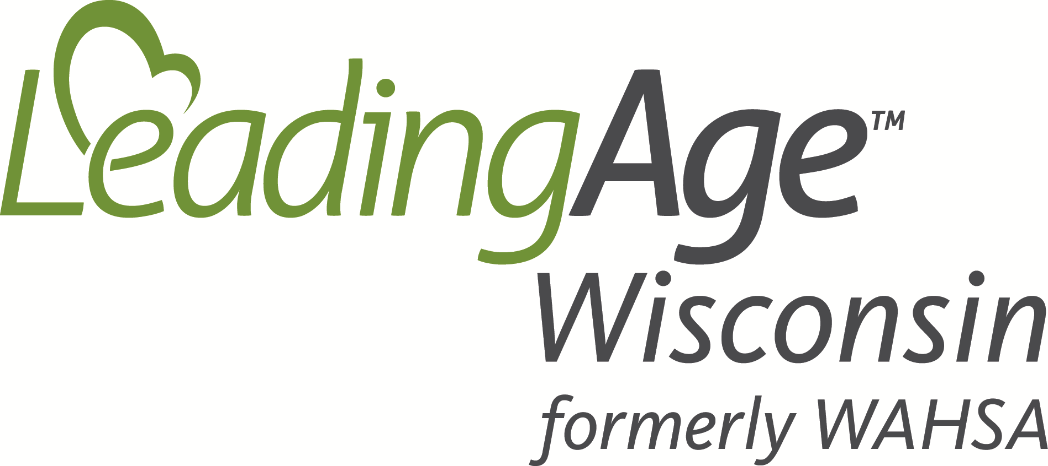
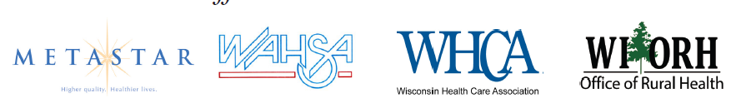
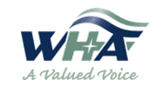
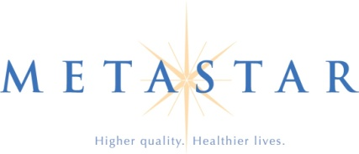
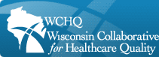
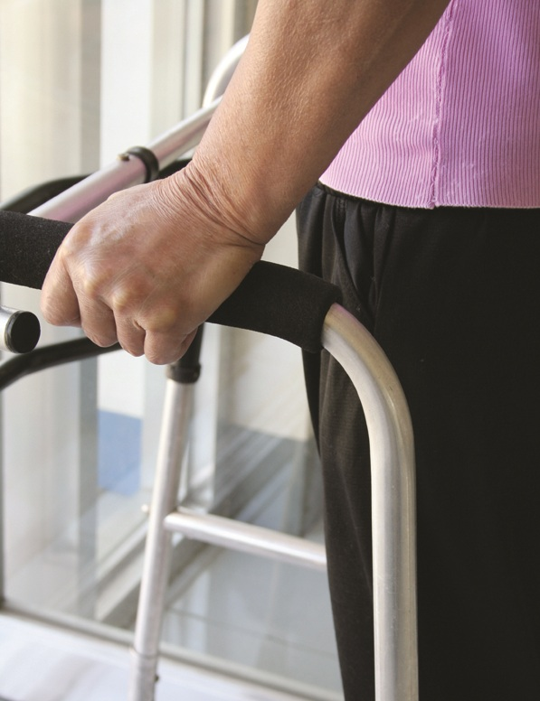
AN UNPRECEDENTED EFFORT
To Learn More:
Informational Webinar
INTERACT II for Skilled Nursing Facilities
June 14 at 1:00 pm.
Register here: http://events.SignUp4.com/12InteractII06-11.12

Join an unprecedented effort to improve care transitions including avoiding unnecessary hospitalizations for Wisconsin residents.
Several organizations have partnered to bring a no-cost collaborative education program to Skilled Nursing facilities in Wisconsin.
- Learn evidence based approaches while trying out components of the INTERACT II approach.
- Practice the PDSA quality improvement model.
- Convene a team to focus on preventable readmissions.

RATIONALE
Medicare is beginning to assess penalties on hospitals that do not have a good readmission rate. Many believe nursing facilities will be the target of similar government imposed penalties for unnecessary re-hospitalizations.
Patients/residents would prefer not to be hospitalized unnecessarily. A focus on improved communication will improve quality of care/life outcomes.
Evidence shows better communication among caregivers reduces the need for readmission.

WHCA | 131 W Wilson St, Ste 1001, Madison, WI 53703 | phone 608.257.0125 | info@whca.com
LeadingAge Wisconsin | 204 S Hamilton St, Madison, WI 53703 | phone 608.255.7060 | info@LeadingAgeWI.org
Hospitals, Nursing Homes, Home Health and Community groups are coming together across the state to work in collaboration – be ready to contribute.

METHOD
- Six monthly webinars
- Learn INTERACT II
- Practice Plan-Do-Study-Act Improvement
- Data collection and submission
- Teamwork skills

