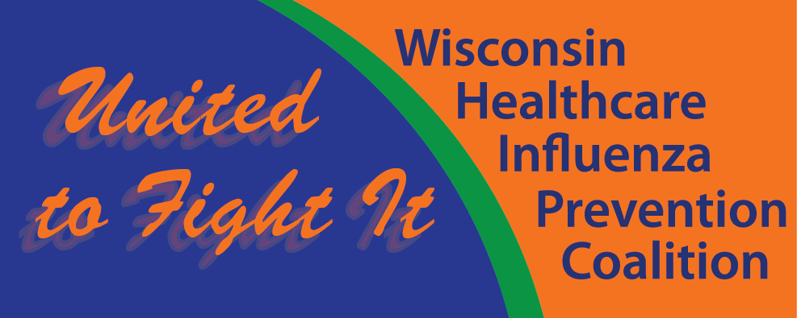

Health Care Personnel
Influenza Vaccination
Implementation Toolkit

Table of Contents

Introduction 1
Overview of Materials Included in the Toolkit 3
National and State Policy Direction 5
Model Policies and Other Forms 8
Influenza Vaccination Medical Exemption Request Form – Part A 12
Influenza Vaccination Medical Exemption Request Form – Part B 14
Influenza Vaccination Religious Exemption Request Form 15
Key References 17
Implementation Timeline and Tips 18
Education and Communications 21
- Template for Letter/Notice to Employees 25
- PowerPoint Slides for Employee Meetings 28
- Myth vs. Fact about the Flu Vaccine 33
- No More Excuses – You Need a Flu Vaccine 35
- Vaccine Fact Sheet 37
- Press Releases 43
- Talking Points for the Media 47
- News Coverage 48
Health Care Personnel Influenza Vaccination Policy Frequently Asked Questions 51
Promising Practices from Wisconsin Hospitals and Health Systems 55
Appendix A: Guidelines for Reporting to CDC-NHSN 56

Introduction
Wisconsin hospitals, physicians, nursing homes and health systems have demonstrated consistent leadership in preventing health care-associated infections. Through the implementation of evidence-based best practices and participation in a variety of national, state and regional improvement initiatives, Wisconsin health care providers have dramatically reduced the occurrence of health care associated infections and greatly enhanced the provision of safe quality care to patients. Each year, influenza results in an estimated 226,000 hospital admissions and 36,000 deaths. Evidence has emerged over the past few years that clearly indicates that health care personnel can unintentionally expose patients to seasonal influenza when health care personnel are not immunized. Exposure to persons infected with the influenza virus can be dangerous to vulnerable patients. Reducing influenza transmission from health care personnel to patients has become a top priority both nationally and in Wisconsin.

Despite longstanding recommendations by a number of national organizations, the response to voluntary vaccination programs has not increased health care personnel influenza vaccination rates to acceptable levels. Wisconsin hospitals that use a voluntary program have average vaccination rates of 72 percent. Nursing homes with a voluntary program are achieving average vaccination rates of 60 percent. Institutions that have implemented a mandatory health care personnel influenza vaccination policy have radically improved health care personnel influenza vaccination rates. Health care organizations that have implemented mandatory programs are achieving average vaccination rates of 99 percent.

To protect the lives and welfare of patients and employees, improve quality and reduce health care costs, Wisconsin Hospital Association (WHA), Wisconsin Medical Society (the Society), LeadingAge Wisconsin, Wisconsin Health Care Association (WHCA)/Wisconsin Center for Assisted Living (WiCAL) and the Pharmacy Society of Wisconsin (PSW) encourage all members to implement an evidence-based vaccination initiative to achieve a vaccination rate of >95 percent as part of their comprehensive approach to prevent health care-associated infections. In support of this goal, our organizations recommend that influenza vaccination become a condition of employment and maintenance of medical staff privileges.

WHA, the Society, LeadingAge Wisconsin, WHCA, WiCAL and PSW recognize Wisconsin health care providers are committed to patient safety. By increasing health care personnel vaccination rates across the state, in hospitals, clinics, nursing homes, pharmacies and health systems, Wisconsin’s health care community will play a vital role in protecting the health and well-being of our patients, families and communities we serve.

Introduction (continued)

Vaccination of health care personnel against influenza not only protects patients and their families, but also protects our valuable workforce against illness. All health care providers are encouraged to work toward influenza vaccination becoming a condition of employment and maintenance of medical staff privileges for the 2013-2014 flu season.

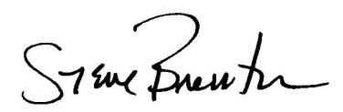
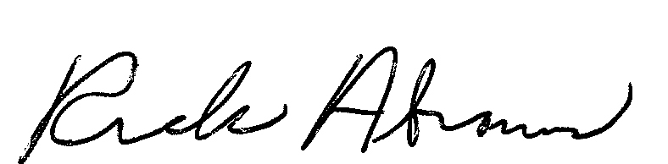

Steve Brenton William “Rick” Abrams
President Chief Executive Officer
Wisconsin Hospital Association Wisconsin Medical Society




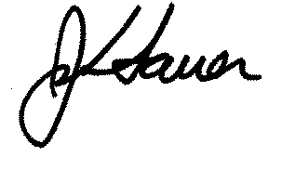

Thomas Moore John Sauer
Executive Director President/Chief Executive Officer
Wisconsin Health Care Association LeadingAge Wisconsin

Wisconsin Center for Assisted Living


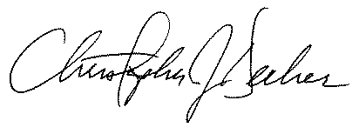

Christopher Decker
Executive Vice President, CEO
Pharmacy Society of Wisconsin


Overview of Materials Included in the Toolkit

The Health Care Personnel Influenza Vaccination Implementation Toolkit is designed to help health care organizations as they work toward implementing policies and practices that require health care personnel to obtain an annual influenza vaccination. The toolkit contains materials that may be used as models. The models are based on successfully implemented policies from other health care organizations. Each health care organization is unique with its own culture, structural, legal and employment considerations. Organizations should obtain independent legal advice in determining the approach that works best in their respective organizations and should feel free to modify the materials contained in the toolkit accordingly.

National and State Policy Direction
This section of the toolkit briefly outlines some of the evidence that supports movement to a program that requires health care personnel influenza vaccinations along with the position statements adopted by several national health care and professional organizations. This section also highlights The Joint Commission standards to achieve a 90 percent health care personnel influenza vaccination rate by the year 2020. Additionally, there are increasing federal and state requirements for reporting vaccination rates and the pending inclusion of these rates in hospital pay-for-performance programs. Wisconsin hospitals, physicians, nursing homes, pharmacists and health systems have demonstrated consistent leadership in preventing health care-associated infections. The implementation of a program that requires influenza vaccination for all health care personnel should be considered an essential element in a comprehensive approach to prevent all health care associated infections.

Model Policies and Other Forms
This section of the toolkit includes the following:
- Policy and Position Statements - This section provides links to other organizations’ policies and position statements on the issue of health care personnel influenza vaccination.
- Model Policy - The model policy was created using several sample policies as well as actual policies developed by several hospitals and health systems in Wisconsin. Organizations will need to modify the policy to fit their unique circumstances.
- Model Medical Exemption from Influenza Vaccination Form – This is a form that can be completed by a qualified medical professional and returned to the health care organization. Organizations are not required to use this form or may elect to modify the form and its content.
- Model Religious Exemption from Influenza Vaccination Form – This is a form that can be completed by personnel and/or their religious leader and returned to the health care organization for review of documented religious exemption requests. Organizations are not required to use this form or may elect to modify the form and its content.

Implementation Timeline and Tips
This section of the toolkit presents a timeline that health care organizations can use to guide the development and implementation of a health care personnel vaccination policy in ample time for the 2013-2014 influenza season.

Education and Communications
This section of the toolkit includes a number of tools that are recommended for use in educating and communicating important information to personnel about influenza vaccination, including communication related to the implementation of a policy that requires vaccination for all health care personnel.

Promising Practices from Wisconsin Health Care Organizations
A number of Wisconsin health care organizations have already implemented programs that require influenza vaccination for all of their health care personnel. Several of these organizations have agreed to share their policies and sample forms to help the entire Wisconsin health care community move toward a similar policy. These policies and forms are found in this section.

National and State Policy Direction

Vaccination remains the single most effective prevention measure available against influenza and can prevent many illnesses, deaths and losses in productivity. Since most health care personnel provide care to, or are in frequent contact with, patients at high risk for complications of influenza, health care personnel are a high priority for expanding vaccine use. Achieving and sustaining high vaccination coverage among health care personnel will protect staff and their patients, reduce disease burden and decrease health care costs.

The Centers for Disease Control and Prevention (CDC) and numerous other professional societies and public health agencies have outlined strategies to improve health care personnel influenza vaccination rates. These have included educational programs that emphasize the importance of health care personnel vaccination for staff and patients, organized campaigns that promote and make vaccine readily available, and vaccination of senior medical staff or opinion leaders as role models. Despite the use of these and other enhanced methods to increase vaccination rates, modest progress has been made in improving health care personnel influenza vaccination rates. About two-thirds of all health care workers got the influenza vaccination during the 2011-12 flu season, and 86 percent of physicians were immunized, said the September 28, 2012 Morbidity and Mortality Weekly Report published by the Centers for Disease Control and Prevention. The immunization rate for health workers in long-term-care facilities was 52 percent, compared with 68 percent in physician offices and 77 percent in hospitals. Health care organizations that require their employees to get flu shots achieve an average immunization rate of 98 percent, the CDC said. Despite long-standing recommendations by the Association for Professionals in Infection Control and Epidemiology, Inc. (APIC), CDC, and other national health care organizations, the response to voluntary vaccination has not risen significantly over the past decade. Even among health care organizations with aggressive voluntary campaigns, 30 percent to 50 percent of health care personnel remain unvaccinated.

The CDC also has recommended that institutions give consideration to the use of signed declination statements for those refusing vaccines. Signed declination policies have been utilized in multiple settings with varying levels of success. A CDC survey that reported responses from 45 organizations with declination policies showed that use of declination policies was associated with only a mean 11.6 percent increase in health care personnel influenza vaccination rates.

Multiple Wisconsin hospitals, physicians, pharmacists, nursing homes and health systems have taken a lead in patient safety by implementing mandatory health care personnel influenza vaccination policies to achieve near 100 percent vaccination rates. WHA conducted a survey of Wisconsin hospitals and health systems in August 2012. The results of this survey (Table 1) show that those hospitals and systems that have implemented a mandatory policy are achieving the highest levels of performance. As part of this same survey over 60 percent of the same organizations reported being supportive of implementing a policy that makes influenza vaccination a condition of employment.

Table 1: WHA Hospital Survey – August 2012
Policy | Average Rates of Vaccination
Vaccination as a condition of employment | 99%
Vaccination or mask | 88%
Vaccination or declination form | 74%
Voluntary vaccination | 72%

The Wisconsin Department of Public Health (DPH) has also studied the effectiveness of vaccination processes in both hospitals (Table 2) and nursing homes (Table 3) for the 2011-2012 influenza season. The DPH study replicates the results obtained by WHA and seen nationally by CDC.

Table 2: DPH 2011–2012 Median Hospital Employee Influenza Vaccination Rates
 | Number of Hospitals | Median Vaccination Rate
Hospitals with mandates | 34 of 131 (26%) | 98%
Hospitals using declination forms | 90 of 131 (69%) | 78%
Hospitals with no mandate or use of declination forms | 7 of 131 (5%) | 73%

Table 3: DPH 2011–2012 Median Nursing Home Employee Influenza Vaccination Rates
 | Number of Hospitals | Median Vaccination Rate
Nursing homes with mandates | 35 of 279 (12%) | 99%
Nursing homes using declination forms | 209 of 279 (75%) | 81%
Nursing homes with no mandate or use of declination forms | 35 of 279 (12%) | 60%

The Joint Commission’s current standards pertaining to influenza vaccination for staff and licensed independent practitioners (IC.02.04.01) include the following:

- The hospital establishes an annual influenza vaccination program that is offered to licensed independent practitioners and staff.
- The hospital educates licensed independent practitioners and staff about, at a minimum, the influenza vaccine; non-vaccine control and prevention measures; and the diagnosis, transmission and impact of influenza.
- The hospital provides influenza vaccination at sites accessible to licensed independent practitioners and staff.
- The hospital includes the goal of improving influenza vaccination rates in its infection control plan.
- The hospital sets incremental influenza vaccination goals, consistent with achieving the 90 percent rate for 2020 (See HHS Action Plan to Prevent Health Care Associated Infections).
- The hospital develops a written description of the methodology used to determine influenza vaccination rates. All hospital staff and licensed independent practitioners are to be included in the methodology for determining the influenza vaccination rates.
- The hospital evaluates the reasons given by staff and licensed independent practitioners for declining the influenza vaccination at regular intervals as defined by the hospital, but at least annually.
- The hospital improves its vaccination rates according to its established goals and at regular intervals as defined by the hospital, but at least annually.

- The hospital provides influenza vaccination rate data to key stakeholders which may include leaders, licensed independent practitioners, nursing staff and other staff at least annually.

Professional societies, including the Association for Professionals in Infection Control and Epidemiology (APIC), Society for Healthcare Epidemiology of America (SHEA), the Infectious Diseases Society of America, Immunization Action Coalition and the American College of Physicians have recommended that influenza vaccination be made mandatory for health care personnel. They point out that even with interventions that promote and provide free and accessible vaccine, health care organizations regularly achieve only 40 percent to 60 percent vaccination rates. In 2011, the American Hospital Association’s Board of Trustees approved a policy supporting mandatory patient safety policies that require either influenza vaccination or wearing a mask in the presence of patients across all health care settings during flu season.

The Centers for Medicare & Medicaid Services (CMS) began requiring all hospitals subject to Inpatient Prospective Payment System (IPPS) rules to report influenza vaccination rates for health care personnel in January 2013, as part of the federal government’s Hospital Inpatient Quality Reporting Program. It is anticipated this measure will be incorporated into the CMS value-based purchasing incentive program for IPPS hospitals. Wisconsin’s Department of Health Services has included health care personnel influenza vaccinations as part of its Medicaid hospital pay-for-performance program that applies to all hospitals. Failure to achieve high rates of vaccination will eventually result in penalties and lost financial incentives for all hospitals.

Health care organizations also benefit from increased vaccination rates. Results of a study published in the New England Journal of Medicine in 1995 (333: 889-893; October 5, 1995) showed that immunized workers had 25 percent fewer upper respiratory illnesses, 43 percent fewer days of sick leave from work due to upper respiratory illness and 44 percent fewer visits to physician offices for upper respiratory illness. The cost savings were estimated to be $46.85 per person vaccinated. This would equate to $68.28 in today’s dollars.

It has been proposed that a public health intervention should be required when it fulfills three criteria: (1) there is clear medical value of the intervention to the individual; (2) the public health benefit of the intervention has been made clear; and (3) when a requirement is the only way to consistently obtain benefit. Using these criteria, required influenza vaccination for health care personnel appears warranted.

Even opponents of required influenza vaccination agree that requiring vaccination is justifiable if comprehensive voluntary immunizations are unsuccessful, which appears to be the case with voluntary health care personnel vaccination programs. Furthermore, health care personnel are already subject to other vaccination requirements, including measles, mumps, rubella, varicella, hepatitis B and tuberculosis testing.

Wisconsin hospitals, clinics, pharmacies, nursing homes and health systems are strongly encouraged to take the necessary steps to implement the recommendations in this toolkit for the 2013-2014 flu seasons if such a program has not already been implemented or plans for such a program for this upcoming flu season are not already underway. Wisconsin health care providers have demonstrated consistent leadership in preventing health care associated infections. The implementation of a policy that requires influenza vaccination of all health care personnel should be considered an essential element in a comprehensive approach to prevent all health care associated infections.

Model Policies and Other Forms
This section of the guidebook includes the following:
- Policy and Position Statements – The following are links to policy documents from organizations that support mandatory influenza vaccination programs for health care personnel:
  - American Hospital Association - http://www.aha.org/advocacy-issues/tools-resources/advisory/2011/110722-quality-adv.pdf
  - American Medical Association - https://ssl3.ama-assn.org/apps/ecomm/PolicyFinderForm.pl?site=www.ama-assn.org&uri=%2fresources%2fdoc%2fPolicyFinder%2fpolicyfiles%2fHnE%2fE-9.133.HTM
  - Association of Professionals in Infection Control and Epidemiology (APIC) - http://www.apic.org/Resource_/TinyMceFileManager/Advocacy-PDFs/APIC_Influenza_Immunization_of_HCP_12711.PDF
  - American Academy of Pediatrics - http://aapnews.aappublications.org/content/31/9/1.3.full
  - Infectious Disease Society of America (IDSA) - http://www.idsociety.org/uploadedFiles/IDSA/Policy_and_Advocacy/Current_Topics_and_Issues/Immunizations_and_Vaccines/Health_Care_Worker_Immunization/Statements/IDSA%20Policy%20on%20Mandatory%20Immunization%20Revision%20083110.pdf
  - National Patient Safety Foundation - http://www.npsf.org/updates-news-press/press/media-alert-npsf-supports-mandatory-flu-vaccinations-for-healthcare-workers/
  - Society for Healthcare Epidemiology of America (SHEA) - http://www.mc.vanderbilt.edu/documents/infectioncontrol/files/2010%20Revised%20SHEA%20PP%20HCW%20Fluvax%20FINAL.pdf

- Model Policy – The model policy was created using several sample policies developed by several hospitals and health systems in Wisconsin. Health care providers will need to modify the policy to fit their unique circumstances. Some health care organizations may elect to have a separate administrative policy or may elect to incorporate the policy into an existing fitness for duty or infection prevention and control policy. Depending on the decisions made by the organization, other health care organization policies may need to be revised. The model policy captures some considerations that health care organizations need to make when crafting their own policy.
- Influenza Vaccination Medical Exemption Request Form – This is a form that can be completed by a qualified medical professional and returned to the health care organization. Organizations are not required to use this form or may elect to modify the form and its content. Alternatively, organizations may require some other documentation other than this form from medical professionals. This form was adapted from other forms developed by Wisconsin hospitals and health systems.
- Influenza Vaccination Religious Exemption Form – This is a form that can be completed and returned to the health care organization for review of documented religious exemption requests. Organizations are not required to use this form or may elect to modify the form and its content. This form was adapted from other forms developed by Wisconsin hospitals and health systems.
Model Health Care Organization Policy

Health Care Organization Policy on Influenza Vaccination for Health Care Personnel

Policy Statement:

It is the policy of the [NAME OF ORGANIZATION] that all individuals working in the [NAME OF ORGANIZATION] are immunized against influenza on an annual basis. Influenza vaccination is a requirement of working at [NAME OF ORGANIZATION]. Individuals working at [NAME OF ORGANIZATION] include employees, credentialed medical staff (as well as their employed or sponsored advanced practice professionals and clinical assistants), students, residents, interns, fellows, volunteers, clergy, contracted personnel and vendors who have contact with patients. [HEALTH CARE ORGANIZATIONS WILL WANT TO PRECISELY DEFINE WHO IS AFFECTED BY THIS POLICY. CONSIDERATION NEEDS TO BE GIVEN TO PEOPLE WHO HAVE DIRECT CONTACT WITH PATIENTS; THOSE WHO DO NOT HAVE DIRECT CONTACT WITH PATIENTS BUT WHO HAVE JOBS THAT PUT THEM IN CLOSE CONTACT WITH PATIENTS OR THE PATIENT ENVIRONMENT; AND THOSE WHO HAVE NO CONTACT WITH PATIENTS OR THE ENVIRONMENT IN WHICH PATIENTS ARE CARED FOR, BUT WHO HAVE CONTACT WITH HEALTH CARE PERSONNEL THAT DO]

Purpose:

The purpose of this policy is to protect the health and safety of patients, health care personnel, patient and health care personnel family members and the community as a whole from influenza infection through annual influenza vaccination.

Procedure:

Annual Influenza Vaccination
- As a condition of employment, maintenance of medical staff privileges or access to patient care or clinical care areas, [NAME OF ORGANIZATION] requires health care personnel to receive an annual influenza vaccination or possess an approved medical or religious exemption.

- Annually, health care personnel, covered by this policy, must do one of the following:
  - Receive the influenza vaccine(s), provided by [INSERT DEPARTMENT NAME THAT WILL ADMINISTER VACCINES], by [INSERT DATE, DECEMBER 1 IS THE LATEST DATE RECOMMENDED].
  - Provide [NAME OF DEPARTMENT OR POSITION TITLE] with proof of vaccination if vaccinated through services other than [NAME OF ORGANIZATION], by [INSERT DATE, DECEMBER 1 IS THE LATEST DATE RECOMMENDED]. Proof of vaccination must include a copy of documentation indicating the vaccine was received. [HEALTH CARE ORGANIZATIONS WILL WANT TO DETERMINE WHAT IS ACCEPTABLE AS PROOF OF INFLUENZA VACCINATION AND ALSO DETERMINE WHERE THE PROOF OF VACCINATION NEEDS TO BE DELIVERED. IN SOME CASES, IT MAY BE EMPLOYEE HEALTH SERVICES OR IT MAY BE OTHER DESIGNATED PEOPLE FOR SPECIFIC TYPES OF HEALTH CARE PERSONNEL, SUCH AS A RESIDENCY DIRECTOR OR THE DIRECTOR OF VOLUNTEER SERVICES]
  - Comply with the designated procedure for obtaining a permissible exception by [INSERT DATE; IT IS RECOMMENDED THIS BE AT LEAST TWO MONTHS PRIOR TO THE FINAL DEADLINE TO ALLOW FOR PROCESSING, NOTIFICATION AND OBTAINING VACCINATION IF THE EXEMPTION IS DENIED], as described in this policy.

- Health care personnel who begin or resume employment, a training rotation or provision of services between October 1 and April 30 are required to receive an influenza vaccination, provide proof of current vaccination status or obtain a medical or religious exemption prior to or on the first day their employment, rotation or service provision begins. [HEALTH CARE ORGANIZATIONS WILL NEED TO DETERMINE THE ABOVE DATES IN ACCORDANCE WITH THE EXPECTED OR ACTUAL INFLUENZA SEASON]

Exemptions:
(NAME OF ORGANIZATION) will grant exemption to annual influenza vaccination for approved medical reasons or religious beliefs.

Medical Exemption
- Exemptions to required vaccination may be granted for certain medical contraindications. Standard criteria will be established and include:
  - Severe allergy to the vaccine or components as defined by the most current recommendations of the CDC’s Advisory Committee on Immunization Practices [HEALTH CARE ORGANIZATIONS MUST DECIDE IF THEY WILL REQUIRE ALLERGY TESTING AND IF THEY WILL PAY FOR THIS TESTING]
  - History of Guillian-Barre’
- An individual requesting medical exemption because of medical contraindications must complete the Medical Exemption Request Form. Part A of the request must be completed and signed by the health care personnel member. Part B of the request must be completed and signed by the health care personnel member’s personal physician. [ORGANIZATIONS MAY ELECT TO USE A STANDARDIZED FORM THAT EMPLOYEES NEED TO HAVE THEIR PHYSICIAN COMPLETE OR MAY ELECT TO IDENTIFY WHAT DOCUMENTATION WOULD BE ACCEPTABLE. IT IS RECOMMENDED THAT THE EMPLOYEE HEALTH NURSE(S) NOT SERVE THIS ROLE.]
- [HEALTH CARE ORGANIZATIONS WILL WANT TO INCLUDE THE PROCESS THEY WILL USE FOR EVALUATING REQUESTS FOR MEDICAL EXEMPTIONS. SOME ORGANIZATIONS PROCESS THESE THROUGH THEIR EMPLOYEE HEALTH SERVICES; OTHERS USE A MEDICAL EVALUATION COMMITTEE. CONSIDERATION SHOULD BE GIVEN TO CONTACTING PERSONAL PHYSICIANS WHO HAVE SIGNED THE FORM FOR REASONS OTHER THAN THE CDC RECOMMENDED EXEMPTIONS.]
- The individual requesting the medical exemption will be notified in writing as to whether his/her request for medical exemption has been granted. If a medical exemption request is denied, the individual will be required to be immunized pursuant to this policy.
- If a medical exemption is granted for a temporary medical condition, the individual must resubmit a request for exemption annually.
- If the exemption is granted permanently, the individual does not need to submit a request for medical exemption annually unless vaccine technology changes and eliminates issues related to allergies.
- [HEALTH CARE ORGANIZATIONS MUST DECIDE WHAT PROCESS, IF ANY, WILL BE USED FOR THOSE WHO HAVE NOT BEEN VACCINATED. CONSIDERATION MUST BE GIVEN TO WHAT PERSONNEL THIS WOULD APPLY TO, UNDER WHAT CONDITIONS, HOW THESE INDIVIDUALS WILL BE IDENTIFIED AND HOW IT WILL BE ENFORCED.][FOLLOWING IS AN EXAMPLE OF A MASKING POLICY - Health care personnel who are not vaccinated, due to a medical exemption, must wear a surgical mask within six (6) feet of any patient and when entering a patient room during the influenza season.]

Religious Exemption
- Exemptions may be granted because vaccination conflicts with the tenets of a religious belief.
- Persons requesting a religious exemption must complete a Religious Exemption Request Form. [ORGANIZATIONS MAY ELECT TO USE A STANDARDIZED FORM THAT EMPLOYEES SHOULD COMPLETE OR MAY ELECT TO IDENTIFY WHAT DOCUMENTATION WOULD BE ACCEPTABLE.]
- [HEALTH CARE ORGANIZATIONS WILL WANT TO INCLUDE THE PROCESS THEY WILL USE FOR EVALUATING REQUESTS FOR RELIGIOUS EXEMPTIONS. SOME ORGANIZATIONS PROCESS THESE THROUGH HUMAN RESOURCES OR MAY MAKE USE OF OTHER DIVERSITY OR ETHICS COMMITTEES.]
- The individual requesting the religious exemption will be notified in writing as to whether his/her request for religious exemption has been granted. If a religious exemption request is denied, the individual will be required to be immunized pursuant to this policy.
- [ORGANIZATIONS MUST DECIDE IF RELIGIOUS EXEMPTIONS ARE PERMANENT OR MUST BE APPLIED FOR EACH YEAR]
- [HEALTH CARE ORGANIZATIONS MUST DECIDE WHAT PROCESS, IF ANY, WILL BE USED FOR THOSE WHO HAVE NOT BEEN VACCINATED. CONSIDERATION MUST BE GIVEN TO WHAT PERSONNEL THIS WOULD APPLY TO, UNDER WHAT CONDITIONS, HOW THESE INDIVIDUALS WILL BE IDENTIFIED AND HOW IT WILL BE ENFORCED.][ FOLLOWING IS AN EXAMPLE OF A MASKING POLICY - Health care personnel who are not vaccinated, due to a religious exemption, must wear a surgical mask within six (6) feet of any patient and when entering a patient room during the influenza season.]

Record Keeping:
[HEALTH CARE ORGANIZATIONS WILL WANT TO IDENTIFY RECORD KEEPING PROCEDURES FOR PROOF OF VACCINATION AS WELL AS FOR EXEMPTIONS. THIS INFORMATION WILL BE IMPORTANT FOR HEALTH CARE ORGANIZATIONS WHEN THEY DETERMINE THEIR INFLUENZA VACCINATION RATES AS WELL AS IF CONFLICTS ARISE WHEN THE HOSPITAL DENIES EXEMPTION REQUESTS.]

[HEALTH CARE ORGANIZATIONS ARE ENCOURAGED TO DESCRIBE RESPONSIBILITY FOR REPORTING VACCINATION RATES TO CDC-NHSN TO ENSURE COMPLIANCE WITH FEDERAL AND STATE REPORTING AND PAY-FOR-PERFORMANCE REQUIREMENTS]

Corrective Action Procedures:
Failure to comply with this vaccination policy will result in a written warning. If an individual is not vaccinated or granted an exemption within two (2) weeks of receiving the warning, that individual will be subject to further corrective action, up to and including termination of employment, automatic relinquishment of medical staff membership and clinical privileges, and/or the forfeiture of the right to continue working and providing services within [ORGANIZATION NAME].

[HEALTH CARE ORGANIZATIONS WILL NEED TO IDENTIFY WHAT CORRECTIVE ACTION STEPS IT WILL TAKE IF AN INDIVIDUAL SUBJECT TO THE POLICY DOES NOT MEET THE ESTABLISHED DEADLINES. SOME ORGANIZATIONS WILL GIVE EMPLOYEES WRITTEN WARNINGS AND ESTABLISH A TIME FRAME UNDER WHICH THE PERSON MUST BE VACCINATED OR OBTAIN AN EXEMPTION BEFORE FURTHER DISCIPLINARY ACTION, INCLUDING TERMINATION OF EMPLOYMENT. OTHER ORGANIZATIONS HAVE OPTED TO PLACE THE EMPLOYEE ON IMMEDIATE LEAVE FOR A CERTAIN AMOUNT OF TIME. IN MOST CASES, HEALTH CARE ORGANIZATIONS PROVIDE A TWO-WEEK TIME PERIOD FOR EMPLOYEES TO COMPLY WITH THE POLICY BEFORE FURTHER DISCIPLINARY ACTION OR TERMINATION OCCURS. ORGANIZATIONS ARE ENCOURAGED TO REVIEW THIS COURSE OF ACTION WITH APPROPRIATE LEGAL COUNSEL.

ORGANIZATIONS ALSO NEED TO CONSIDER WHAT ACTIONS THEY WILL PUT IN PLACE FOR OTHER INDIVIDUALS WHO ARE SUBJECT TO THE HEALTH CARE ORGANIZATION POLICY BUT ARE NOT EMPLOYEES OF THE HEALTH CARE ORGANIZATION INCLUDING MEMBERS OF THE MEDICAL STAFF.

ORGANIZATIONS THAT HAVE LABOR AGREEMENTS COVERING SOME OR ALL OF THEIR EMPLOYEES SHOULD CONSIDER WORKING WITH THOSE UNION(S) IN DEVELOPING A HEALTH CARE PERSONNEL VACCINATION POLICY AND THE CONSEQUENCES ASSOCIATED WITH BARGAINING UNIT EMPLOYEES WHO FAILURE TO COMPLY WITH THE HEALTH CARE ORGANIZATION POLICY.]

Infection Control Procedures:
- All individuals are responsible for monitoring their health status and reporting to work only when they are not in a status that would put others at risk of contracting an infection, whether viral or bacterial.
- All employees are responsible for performing appropriate infection control standards to prevent risk to others and themselves. This includes, but is not limited to, frequent hand washing, masking, covering coughs and sneezes, disinfecting equipment and work stations, and not reporting to work when ill.

Vaccine Shortages:
In the event of an influenza vaccine shortage, the situation will be evaluated by [NAME OF ORGANIZATION], relying on the expertise of employee health services, infection prevention and control, human resources, pharmacy, management and medical leadership. Influenza vaccination will be offered to personnel based on job function and risk of exposure to influenza. Priority will be established in concordance with the recommendations by the Department of Public Health.

[HEALTH CARE ORGANIZATIONS WILL WANT TO IDENTIFY WHAT PROCESS THEY WILL USE WHEN THERE IS A SHORTAGE OF VACCINE AVAILABLE. ORGANIZATIONS MAY HAVE ALREADY FACED THIS IN PREVIOUS FLU SEASONS OR DURING THE H1N1 EPIDEMIC AND WILL WANT TO REVIEW THE PROCEDURES THAT THEY USED DURING THOSE SITUATIONS.]

[ORGANIZATION’S LOGO]

Influenza Vaccination
Medical Exemption Request Form – Part A

Instructions
1. Complete and sign this page.
2. Present Part B to your health care provider to complete the medical information.
3. Return both completed forms to [INSERT WHERE FORMS SHOULD BE RETURNED TO] by [INSERT DEADLINE FOR SUBMISSION OF FORMS].

Name: _______________________________________ Date of Birth: _________________________

Position Title: ________________________________ Department: _________________________

Employee ID: _______________________________

[ORGANIZATION NAME] is committed to protecting our patients, health care workers, volunteers, medical staff practitioners, students [THE CATEGORIES OF HEALTH CARE WORKERS LISTED HERE SHOULD MATCH WHAT IS LISTED IN THE POLICY] and the community from influenza. Influenza is a serious respiratory disease that kills an average of 36,000 people and hospitalizes more than 200,000 people in the United States each year. A person who comes in contact with the influenza virus can shed it for 24 to 48 hours before symptoms may appear. This can spread the virus to patients in [ORGANIZATION NAME] facilities, to colleagues, and to family members. [ORGANIZATION NAME] requires all health care personnel as defined in policy [INSERT POLICY NAME AND/OR NUMBER] to be vaccinated against influenza on an annual basis, unless granted an exemption. This form is used to request a medical exemption. Pursuant to policy [INSERT POLICY NAME AND/OR NUMBER], only the following individuals are entitled to medical exemptions:

- Individuals with a previous reaction to the influenza vaccine such as hives, difficulty breathing, or swelling of the tongue or lips. This category does not include individuals with mere sensitivity to the vaccine such as an upset stomach or mild to moderate local reactions such as soreness, redness, itching or swelling at the injection site.

- Individuals with a severe egg allergy.

- Individuals with a history of Guillain Barré Syndrome.

- Individuals with other compelling medical need for an exemption.

Individuals who do not receive a vaccination because they are granted an exemption must [INSERT ORGANIZATIONAL REQUIREMENTS, IF ANY, IF A VACCINE IS NOT RECEIVED]

With knowledge of the above, I am requesting an exemption from the influenza vaccination for medical reasons.

Signature: ______________________________________ Date: __________________

Section below is to be completed by [NAME OF REVIEW BODY]

This was reviewed by the Exemption Committee on ______________ and determined that
Date

- Qualifies for exemption. ◻ Does not qualify for exemption.

Further actions to be taken include:

The person requesting the medical exemption was notified of the results of the review on _____________ (date)

by _____________________________________________

[ORGANIZATION’S LOGO]

Influenza Vaccination
Medical Exemption Request Form – Part B
To be completed by requestor’s personal health care provider

Patient Name: ____________________________________ Date of Birth_____________________

[ORGANIZATION NAME] is committed to protecting our patients, health care personnel and the community from influenza. Our influenza vaccination safety initiative requires our health care personnel, without sincerely held religious objections or medical contraindications, to receive an annual influenza vaccine. Your patient is requesting a medical exemption from receiving the influenza vaccination. Medical exemptions are granted for recognized contraindications.

Guidance for medical contraindications can be obtained from the Center for Disease Control and Prevention publication, Morbidity and Mortality Weekly Report (MMWR) August 17, 2012/61(32): 613-618, Prevention and Control of Influenza with Vaccines: Recommendations of the Advisory Committee on Immunization Practices (ACIP) – United States, 2012-13 Influenza Season. This can be found at the following website, http://www.cdc.gov/vaccines/pubs/ACIP-list.htm
____________________________________________________________________________________

Please clarify your patient’s contraindications to the influenza vaccine:

☐ Previous reaction to influenza vaccine (e.g. hives, difficulty breathing, swelling of tongue or lips)
- The above does not include sensitivity to the vaccine such as an upset stomach or mild to moderate local reactions such as soreness, redness, itching, or swelling at the injection site.
- The above does not include subsequent upper respiratory infection or low-grade or moderate fever following a prior dose of the vaccine.

Description of Reaction: ____________________________________________________________
Date of Reaction: _________________________

☐ Severe Egg Allergy (note recent ACIP recommendations below)
- If patient can eat a lightly cooked egg (e.g. scrambled egg) without reaction then administer vaccine per usual protocol.
- If after eating eggs or egg containing foods, the patient experiences ONLY hives then administer TIV and observe for reaction for at least 30 minutes after vaccination.
- If a patient experiences cardiovascular changes (e.g. hypotension), respiratory distress (e.g. wheezing), gastrointestinal symptoms (e.g. nausea/vomiting), reaction requiring epinephrine or reaction requiring emergency medical attention then refer to a physician with expertise in management of allergic conditions for further evaluation.

Description of Reaction: ____________________________________________________________
Date of Reaction: _________________________

☐ History of Guillain Barré Syndrome
Date Patient had GBS:______________________________
- Patient may still receive vaccine if they desire

☐ Other – (please describe reaction and date):

To a responsible degree of medical certainty, it is my opinion that my patient referenced above has the influenza contraindication as identified.

Provider’s Signature _____________________________________________________ Date __________________

Provider’s Name _______________________________________________________________

Address _________________________________________ Phone ________________________

[ORGANIZATION’S LOGO]

Influenza Vaccination
Religious Exemption Request Form

Instructions
1. Read, complete and sign this page.
2. Return the completed form to [INSERT WHERE FORMS SHOULD BE RETURNED TO] by [INSERT DEADLINE FOR SUBMISSION OF FORMS].

Name: _______________________________________ Date of Request: _________________________

Position Title: ________________________________ Department: _________________________

Employee ID: _______________________________

[ORGANIZATION NAME] is committed to the diversity and inclusiveness of all our entire health care team. I understand that [ORGANIZATION NAME] requires all health care personnel as defined in policy [INSERT POLICY NAME AND/OR NUMBER] to be vaccinated against influenza on an annual basis, unless granted an exemption. A religious conviction exemption will ONLY be granted if a vaccination violates the tenets of a personally held religious belief.

Please read the following:
- Influenza is a serious respiratory disease that kills an average of 36,000 persons and hospitalizes more than 200,000 persons in the United States each year.
- Influenza vaccination is recommended for me and all other health care personnel to protect our patients from influenza disease, its complications and death.
- I am likely to be exposed to the influenza virus through the community and could bring the illness into the health care setting.
- If I contract influenza, I will shed the virus for 24 to 48 hours before influenza symptoms appear. My shedding the virus can spread the influenza disease to patients in this facility and to my colleagues and family.
- If I become infected with influenza, even when my symptoms are mild or non-existent, I can spread severe illness to others.
- I understand that the strains of virus that cause influenza infection change almost every year, which is why a different influenza vaccination is recommended each year.
- I understand that I cannot get influenza from the influenza vaccine.
- The consequences of my not being vaccinated could have life-threatening consequences to my health and the health of those with whom I have contact, including:
  - Patients utilizing our services
  - My co-workers
  - My family
  - My community
- I understand that not being vaccinated as a result of an exemption will require me to [INSERT ORGANIZATIONAL REQUIREMENTS, IF ANY, IF A VACCINE IS NOT RECEIVED]

Despite these facts, I am requesting an exemption from the required influenza vaccine for the following sincerely held religious beliefs.

Certification:

By my signature below, I acknowledge that I have read and fully understand the information on this form. I certify that influenza vaccination violates the tenets of my religious beliefs, and that my beliefs – not my medical objection to vaccinations – are the motivation for my request. I also understand that I may be contacted and I authorize my religious leader (if identified) to be contacted to provide further clarification. I also understand that my request for an exemption may not be granted if it is not reasonable or creates an undue hardship on my employer. I understand that any false or incomplete information on this form will result in disciplinary action up to and including termination of employment for falsification of records.

Signature:_______________________________________________ Date:

Section below is to be completed by [NAME OF REVIEW BODY]

This was reviewed by the Exemption Committee on ______________ (date) and determined that

- Qualifies for exemption. ◻ Does not qualify for exemption.

Further actions to be taken include:

The requestor was notified of the results of the review on _____________ (date)

by _____________________________________________

Key References

Tomas R. Talbot, Hilary Babcock, Arthur L. Caplan, Deborah Cotton, Lisa L. Maragakis, Gregory A. Poland, Edward J. Septimus, Michael L. Tapper, David J. Weber, (October 2010). Revised SHEA Position Paper: Influenza Vaccination of Healthcare Personnel. Infection Control and Hospital Epidemiology, Vol. 31, No. 10.

Hilary M. Babcock, Nancy Gemeinhart, Marilyn Jones, Claieborne W. Dunagan, Keith F. Woeltje, (2010). Mandatory Influenza Vaccination of Health Care Workers: Translating Policy to Practice. Clinical Infectious Disease, 2010:50, 459-464.

Gregory A. Poland, Pritish Tosh, Robert M. Jacobson, (2005). Requiring influenza vaccination for health care workers: seven truths we must accept. Vaccine, 23, 2251-2255.

B. J. Cowling, Y. Zhou, D. K. Ip, G. M. Leung, A.E. Aiello, (2010). Face masks to prevent transmission of influenza virus: a systematic review. Epidemiol. Infec., 138, 449-456.

American College of Physicians, ACP Policy on Influenza Vaccination of Health Care Workers, http://www.acponline.org/clinical_information/resources/adult_immunization/flu_hcw.pdf

APIC, APIC Position Paper: Influenza Vaccination Should Be a Condition of Employment for Healthcare Personnel, Unless Medically Contraindicated, http://www.apic.org/Resource_/TinyMceFileManager/Advocacy-PDFs/APIC_Influenza_Immunization_of_HCP_12711.PDF

Infectious Disease Society of America, IDSA Policy on Mandatory Immunization of Health Care Workers Against Seasonal and Pandemic Influenza, http://www.idsociety.org/uploadedFiles/IDSA/Policy_and_Advocacy/Current_Topics_and_Issues/Immunizations_and_Vaccines/Health_Care_Worker_Immunization/Statements/IDSA%20Policy%20on%20Mandatory%20Immunization%20Revision%20083110.pdf

U.S. Equal Employment Opportunity Commission, Pandemic Preparedness in the Workplace and the Americans with Disabilities Act, http://www.eeoc.gov/facts/pandemic_flu.html

U.S. Equal Employment Opportunity Commission, Letter regarding religious exemptions, http://www.eeoc.gov/eeoc/foia/letters/2012/religious_accommodation.html

Implementation Timeline and Tips

This section of the toolkit presents a timeline for health care organizations to use to achieve consensus on a health care personnel influenza vaccination policy that can be implemented in ample time for the 2013-2014 influenza season. There are a number of organizations that have implemented such a policy or plan on implementing such a policy for the upcoming influenza season. Organizations that have not made a commitment to adopt this policy are strongly encouraged to exhaust all voluntary efforts to achieve 95 percent or greater vaccination rates among health care personnel.

The goal of an influenza vaccination policy for health care personnel is to administer the influenza vaccine to as many health care personnel as possible, preferably before influenza activity in the community begins. In Wisconsin, seasonal influenza typically ranges from November to as late as May, most commonly peaking in late February or March. The optimal time to vaccinate health care personnel is October and November, but vaccinations should be made available as long as the vaccine is available.

March
- Obtain senior leadership buy-in for the organizational approach. Consideration should be given to obtaining input from the chief executive officer, chief medical officer/chief of staff, chief nursing officer/director of nursing, infection prevention department (chief infectious disease physician, infection preventionist), human resources/employee health, compliance and legal counsel.
- Develop a strategy for obtaining support from applicable unions.
- Develop or update your formal policy on vaccination of health care personnel and receive appropriate approval.
- Review and update Medical Staff Rules and Regulations and obtain Medical Executive Committee approval.
  - Sample language: “Failure to provide proof of influenza vaccination, or granted exemption, in accordance with [INSERT POLICY NAME AND/OR NUMBER] within 30 days after receiving written notice of delinquency describing the failure to comply with the [INSERT POLICY NAME AND/OR NUMBER] shall be deemed a voluntary relinquishment of Medical Staff appointment and clinical privileges.
- Create a task force to oversee implementation of the policy. The task force should include a champion from key areas and departments within the organization. Choose people who will help roll-out the plan in their respective areas.

April – May
- Determine your budget and action plan. Have pharmacists plan for the appropriate expected volume of vaccine that would be necessary for an expected increase in administration.
- Meet with senior leadership to review issues and approve implementation. Ask them to take an active role in encouraging influenza vaccination compliance by receiving the vaccine first.

June – July
- Develop your theme (involve employees if possible).
- Develop the policy roll-out strategy, including an employee education component. Studies have shown that much of the employee resistance to such efforts is due to misinformation.
- Order printed materials: buttons, posters and stickers.

August
- Finalize logistics for administration of vaccine, including staffing plans for administration. Arrange for volunteer and “per diem” nursing and administrative staff if needed. Review appropriate vaccine administration risk assessment and techniques with those who will be administering the vaccine.
- Ensure convenient access
  - Consider using rolling influenza vaccine carts that can be taken to all departments during all shifts, including the cafeteria, grand rounds, medical records, etc.
  - Offer peer vaccination on patient care units, if possible.
  - Hold influenza vaccination clinics at several different dates and times.
  - Coordinate vaccination clinics with other activities such as benefit fairs, annual in-service sessions, meetings or annual TB skin testing to make it easy and convenient for health care personnel to attend.
- Consider beginning the education portion of the campaign this month, before kicking off the vaccination portion of the campaign. Use task force champions from multiple areas, departments and disciplines assist with education.
- Inform vendors and other external agencies that send personnel to the organization of the new requirement.

September – October
- Arrange for the CEO and other members of the leadership team including Board members to be among the first vaccinated. Encourage them to wear “I received my flu shot” stickers (or other identifying item you may consider) to build public support for the campaign. Take a photo of them being immunized and publish it in employee communications.
- Administer vaccinations to health care personnel employees, monitor daily operations and pinpoint ways to improve efficiency.
- Begin to generate weekly status reports for local managers.

November/December
- Monitor vaccination rates, troubleshoot problems and brainstorm ways to reach the health care personnel who have not been immunized.
- Continue administering influenza vaccinations at convenient locations on- and off-site as needed.
- Ensure there is an ongoing process throughout the flu season to vaccinate all new health care personnel.
- Closely monitor, track and analyze vaccination rates. Communicate vaccination rates on a regular basis to everyone in the organization.
- Work with local managers to ensure there is fair and consistent implementation of disciplinary actions as outlined in your policy.
- Listen to health care personnel early and often, especially during the first year, which is critical.

January/February/March
- Continue to vaccinate all new health care personnel.
- Develop preliminary estimates of vaccine order quantities for the next flu season.
- Order additional vaccine.

April/May/June
- Evaluate your efforts, including:
  - How many health care personnel were immunized?
  - How does that compare with previous years?
  - How many requested and were granted an exemption?
  - How many disciplinary actions were taken?
  - Was the vaccine supply appropriate for the demand?
- Annually report your statistics to CDC-NHSN by May 15 to ensure your hospital is compliant with federal and state reporting requirements and pay-for-performance programs. The guidelines for reporting to CDC-NHSN can be found in Appendix A.
- Communicate the vaccination results. If you are a Joint Commission accredited organization this should include leaders, medical staff, nursing staff and other staff.
- Make recommendations for changes to your policy and supporting procedures. Develop a budget for the upcoming flu season.

Education and Communications

Wisconsin hospitals, physicians, pharmacists, nursing homes and health systems have demonstrated consistent leadership in preventing health care-associated infections. To protect the lives and welfare of patients and employees, improve quality and to reduce health care costs, a coalition initially comprised of the Wisconsin Hospital Association, Wisconsin Medical Society, LeadingAge Wisconsin, Wisconsin Health Care Association (WHCA)/Wisconsin Center for Assisted Living (WiCAL) and the Pharmacy Society of Wisconsin (PSW) came together to encourage all their members to implement an evidence-based vaccination initiative to achieve a vaccination rate of >95 percent as part of their comprehensive approach to prevent health care-associated infections. In support of this goal, these organizations recommend that influenza vaccination become a condition of employment and maintenance of medical staff privileges.

Collectively, this effort is called:

“United to Fight It”
The Wisconsin Healthcare Influenza Prevention Coalition (WHIPC)

Some hospitals and health systems have already implemented a policy similar to the one adopted by the five statewide health associations.

Each hospital and health system can either decide to use the new, statewide materials or continue to use the materials that you have used in the past, or you can create a new campaign to promote influenza immunizations among your employees. Some hospitals achieve high levels of employee influenza and do it without any posters or campaign materials. That is an option as well.

The following information can be found in this section:

- Internal communications
  - Notice/letter to Employees
  - Myth v Fact
- Patient and Visitor Information
  - Badge sticker examples, vendor
  - Media and Talking Points

Internal Communications

Informing Employees
Communicating the policy to employees is the first step. If it is a change in a personnel policy, it is suggested that a notice be sent directly to the employee’s home address.
The change in policy can also be sent through the organization’s email system or through the intranet. The important point is to ensure that all employees receive the notice and have an opportunity to ask questions.

- A template for a letter/notice to employees can be found on page 24 or at http://www.wha.org/data/sites/1/influenza/SampleEmployeeLetterOnPolicy.doc

Meeting with Employees
Some of the hospitals that have implemented policies report that the best way to ensure that all employees know the policy is to work with managers and develop tools for them to use to inform their employees of the policy. During that meeting the managers should be prepared to:

- Explain why it is important
- Follow up with information related to when/where employee flu clinics will be held
- Provide communications materials for managers to use at staff meetings:
  - Script and PowerPoint slides for employee meetings – attention to infection prevention aspect, keeping employee, patient and their families well (see page 25 or http://www.wha.org/data/sites/1/influenza/HealthCarePersonnel.ppt)
  - Hard copies of the policy (see sample on page 9 or http://www.wha.org/data/sites/1/influenza/modelHealthCareOrganizationPolicy.doc)
  - Hard copies of a Q and A on the policy (see page 44 or http://www.wha.org/data/sites/1/influenza/FAQs.doc)
  - Hard copies of a Myths v Facts About Vaccine (see p. 30-31 or http://www.wha.org/data/sites/1/influenza/mythvsfact.pdf)
  - Centers for Disease Control – No Excuses (see p. 32-33 or http://www.cdc.gov/flu/pdf/freeresources/general/no-excuses-flu-vaccine.pdf)
  - Hard copies of the Vaccine Fact Sheet (technical ) (see page 34-35 or http://www.cdc.gov/vaccines/pubs/vis/downloads/vis-flu.pdf)
  - An explanation of the “religious and medical reasons” (see FAQs, page 44)

Visible Designation of Vaccination Status
Each hospital will need to make a decision whether they want to have a visible designation on employee name badges or a pin on those that are immunized.

Visible designation allows patients to see that the hospital employees have received the vaccination for the patient’s protection. It also communicates their immunization status more broadly to visitors and to the community.


If the hospital implements the policy, then only a small handful of employees will have waivers to not have received the immunization so 95 percent or more of the employees will have received the shot. That may negate the necessity to visibly demonstrate an employee’s immunization status.

To order the generic orange removable “I got my FLU SHOT for YOU” badge sticker pictured at right, contact:

Chuck Moore, Ad Aids, Inc.
adaids@centurytel.net
800-223-2542; La Crosse, Wisconsin

Getting the Word Out: Employee Flu Clinics
The hospitals that have the highest immunization rates plan around employee’s work schedules to ensure that getting the shot is quick and easy. Here are a few ideas.

- “Have Cart: Will Travel”: Monroe Clinic
(http://www.wha.org/pubArchive/valued_voice/vv3-18-11.htm#8)
- “The ‘Flu Light Special’ Cart’”: Spooner Health Center (http://www.wha.org/pubArchive/valued_voice/vv1-7-11.htm#9)
- Physicians Lead the Way: Prairie du Chien Memorial Hospital (http://www.wha.org/pubArchive/valued_voice/vv12-10-10.htm#11)

Frequently Asked Questions and Talking Points
Employees will have questions about the new policy. WHA has prepared a frequently asked questions document that is available on page 44 of this document or at http://www.wha.org/data/sites/1/influenza/FAQs.doc. This document will address most of the questions that employees will have about the influenza policy.

As hospitals have implemented employee influenza vaccination policies, some have chosen a proactive approach with the press; others chose a reactionary stance and handle press or outside inquiries about the policy on a case-by-case basis. There is no right answer.

If a proactive approach is employed, here are two examples of how a policy was communicated to the public. Be aware, however, that the Coalition is supporting an employee immunization policy that does not count masking toward achieving the goal of having more than 95 percent of employees vaccinated. Each health care system will need to make a decision about masking.

Joint news releases among several health organizations are an effective way to message a new policy (see Theda/Affinity news release on page 36 or at http://www.wha.org/data/sites/1/influenza/Thedacare-AffinityFluAnnounce8-12.pdf)

A proactive release example: (see Ministry Door County Medical Center’s news release on page 38 or at http://www.wha.org/data/sites/1/influenza/MDCMCoffersFluVaccine.doc.

Talking Points – For Press and Public
Whether a proactive or reactive position is chosen, it is always helpful to have talking points readily available. Talking points are available on page 40 or at: http://www.wha.org/data/sites/1/influenza/TalkingPointsFluShots2013FINAL.doc

Press Coverage on Influenza Policies
It is helpful to see the press coverage on this topic. Below are some links that provide some background on how the press has covered health care influenza vaccination policies in the past.

“UW Health requires flu shots” Wisconsin State Journal (November 12, 2012)
http://host.madison.com/wsj/news/local/health_med_fit/uw-health-requires-flu-shots/article_e85fde19-082a-5ea3-9aa1-7e91f6c36d86.html (also on page 41)

“Aurora boosts flu vaccination rate with new policy” Journal Sentinel (May 9, 2012): http://www.jsonline.com/blogs/news/150853915.html (also on page 43)

Template for Letter/Notice to Employees
(NAME OF ORGANZATION) has consistently demonstrated leadership in our community to prevent health care-associated infections. We, along with other Wisconsin health care providers, have dramatically reduced the occurrence of health care associated infections and greatly enhanced the provision of safe quality care to patients. But, we need to do even more.

Each year, influenza results in an estimated 226,000 hospital admissions and 36,000 deaths. Evidence has emerged over the past few years that clearly indicate that health care personnel can unintentionally expose patients to seasonal influenza when health care personnel are not immunized. Exposure to persons infected with the influenza virus can be dangerous to vulnerable patients. Reducing influenza transmission from health care personnel to patients has become a top priority both nationally and in Wisconsin.

Starting now, we are implementing a new employee health influenza immunization policy.
(NAME OF ORGANZIATION) employees will be required to receive an influenza vaccination as a condition of employment and maintenance of medical staff privileges.

We join other hospitals, nursing homes, medical clinics and pharmacies in implementing this policy as collectively, the goal is to achieve a vaccination rate greater than 95 percent in our health care organizations. The Wisconsin Healthcare Influenza Prevention Coalition, a group comprised of the Wisconsin Hospital Association (WHA), Wisconsin Medical Society (the Society), LeadingAge Wisconsin, Wisconsin Health Care Association (WHCA)/Wisconsin Center for Assisted Living (WiCAL) and the Pharmacy Society of Wisconsin, is encouraging all their members to implement an evidence-based vaccination initiative to achieve a vaccination rate of >95 percent. Attaining this goal will help to prevent health care-associated infections, protect the lives and welfare of patients and employees, improve quality and reduce health care costs.

This goal aligns with our mission and helps us meet our goal to provide the highest quality, safest patient care possible.

By increasing health care personnel vaccination rates across the state, in hospitals, clinics, pharmacies, nursing homes and health systems, Wisconsin’s health care community will play a vital role in protecting the health and well-being of our patients, families and people residing in the communities we serve.

More details on our policy will be available at (employee meetings, staff meetings, etc).

Sincerely,
(NAME, TITLE)

Health Care Personnel
Influenza Vaccination

[ORGANIZATION NAME]
[ORGANIZATION LOGO]

- Each year, influenza results in an estimated 226,000 hospital admissions and 36,000 deaths.

The Facts:
- The flu is a contagious respiratory illness caused by influenza viruses. It can cause mild to severe illness, and at times can lead to hospitalization and death.
- The main way that influenza viruses spread is from person to person in respiratory droplets of coughs and sneezes. It also may be spread when a person touches the droplets on another person or an object and then touches their own mouth or nose (or someone else’s mouth or nose) before washing their own hands.

More Facts
- Most healthy adults can infect others beginning one day before symptoms develop and up to 5-7 days after becoming sick. Children may pass the virus for more than seven days.
- Some people, such as older adults, pregnant women, and very young children, as well as people with certain long-term medical conditions, are at high risk of serious complications from the flu.

More Facts
- Influenza vaccination is the most effective way to prevent influenza among our patients and staff.
- The CDC recommends that all health care personnel receive the vaccine.

What can I do?
- Health care personnel have a special role in the fight against influenza.
  - By getting vaccinated, health care personnel can protect their health, their families’ health, and the health of their patients.
  - High rates of vaccination have been linked to improved patient outcomes and reduced absenteeism and influenza among staff.

Influenza Vaccination:
- [Organization] is committed to protecting you, your family, and our patients. It is about our commitment to safety.
- [Organization] recognizes that influenza vaccination is the most effective way to prevent influenza infection among our patients and staff.
- [Organization] will require health care personnel to receive annual influenza immunizations as a condition of employment and maintenance of clinical privileges.

[ORGANIZATION NAME] Policy:
- It is the policy of [ORGANIZATION] that all individuals are immunized against influenza on an annual basis.
- Influenza vaccination is a requirement of working in [HOSPITAL NAME].
- Individuals include employees, residents, students, members of the medical staff, volunteers, and contracted personnel. [PRECISELY DEFINE WHO IS AFFECTED BY THIS POLICY]

Exemptions
- Exemptions may be requested for medical reasons or religious beliefs.
- If an exemption is granted, the individuals may be required to wear a surgical mask, may be reassigned if working in a high-risk area, or may need to conform with other alternative infection prevention and control measures [INSERT WHAT WILL BE REQUIRED] while at work during the time frame indentified by [ORGANIZATION] based on influenza activity in Wisconsin.

Will I Get Sick from the Vaccine?
- Influenza vaccines cannot cause the flu. The viruses in flu vaccines are either killed (the flu shot) or weakened (the nasal spray vaccine). The vaccines work by priming your body’s defenses in case you are exposed to an actual influenza virus.
- Influenza vaccines are safe. Serious problems from the influenza vaccine are very rare.
- The most common side effect that a person is likely to experience is soreness where the injection was given. This is generally mild and usually goes away after a day or two.

Vaccine Options
- Flu shot: A vaccine with killed virus given by needle injection. It is approved for use in people older than six months, including healthy people and people with chronic medical conditions.
- Nasal spray vaccine: A vaccine with weakened live viruses. It is approved for use in healthy people 2 to 49 years of age.
- Please discuss your concerns and questions with our employee health department.

Who Should Not Get a Vaccine?
- People who have documented severe allergy to chicken eggs.
- People with a history of Guillain-Barre Syndrome
- Children less than six months of age.
- People who have moderate to severe illness with a fever (they should wait until they recover to get vaccinated).
- Please discuss your concerns and questions with our employee health department.

Other Things You Can Do
- Influenza vaccination is part of [ORGANIZATION]’s comprehensive approach to prevent health care-associated infections. Once being vaccinated, remember these basic practices to help protect patients and yourself:
- Wash your hands.
- Cover your cough.
- Stay home if you have influenza-like symptoms (fever or feeling feverish/chills, cough, sore throat, runny or stuffy nose, muscle or body aches, headaches, and fatigue/tiredness).

Standard Precautions
- It is important to practice strict standard precautions when caring for all patients:
- Wash or gel hands before and after every patient contact.
- Wear gloves for all procedures and contact with mucous membranes or bodily secretions.
- Wear gown when exposure to bodily fluids is likely.
- Wear a mask whenever performing cough-inducing or aerosol-generating procedures.

Next Steps
- A memo will be posted [DATE] to all employees with a copy of our new policy and additional information about when and where you can receive your vaccination.
- If you have further questions, please contact our employee health department at [Phone Number] or [Email Address].
- Thank you for your support!

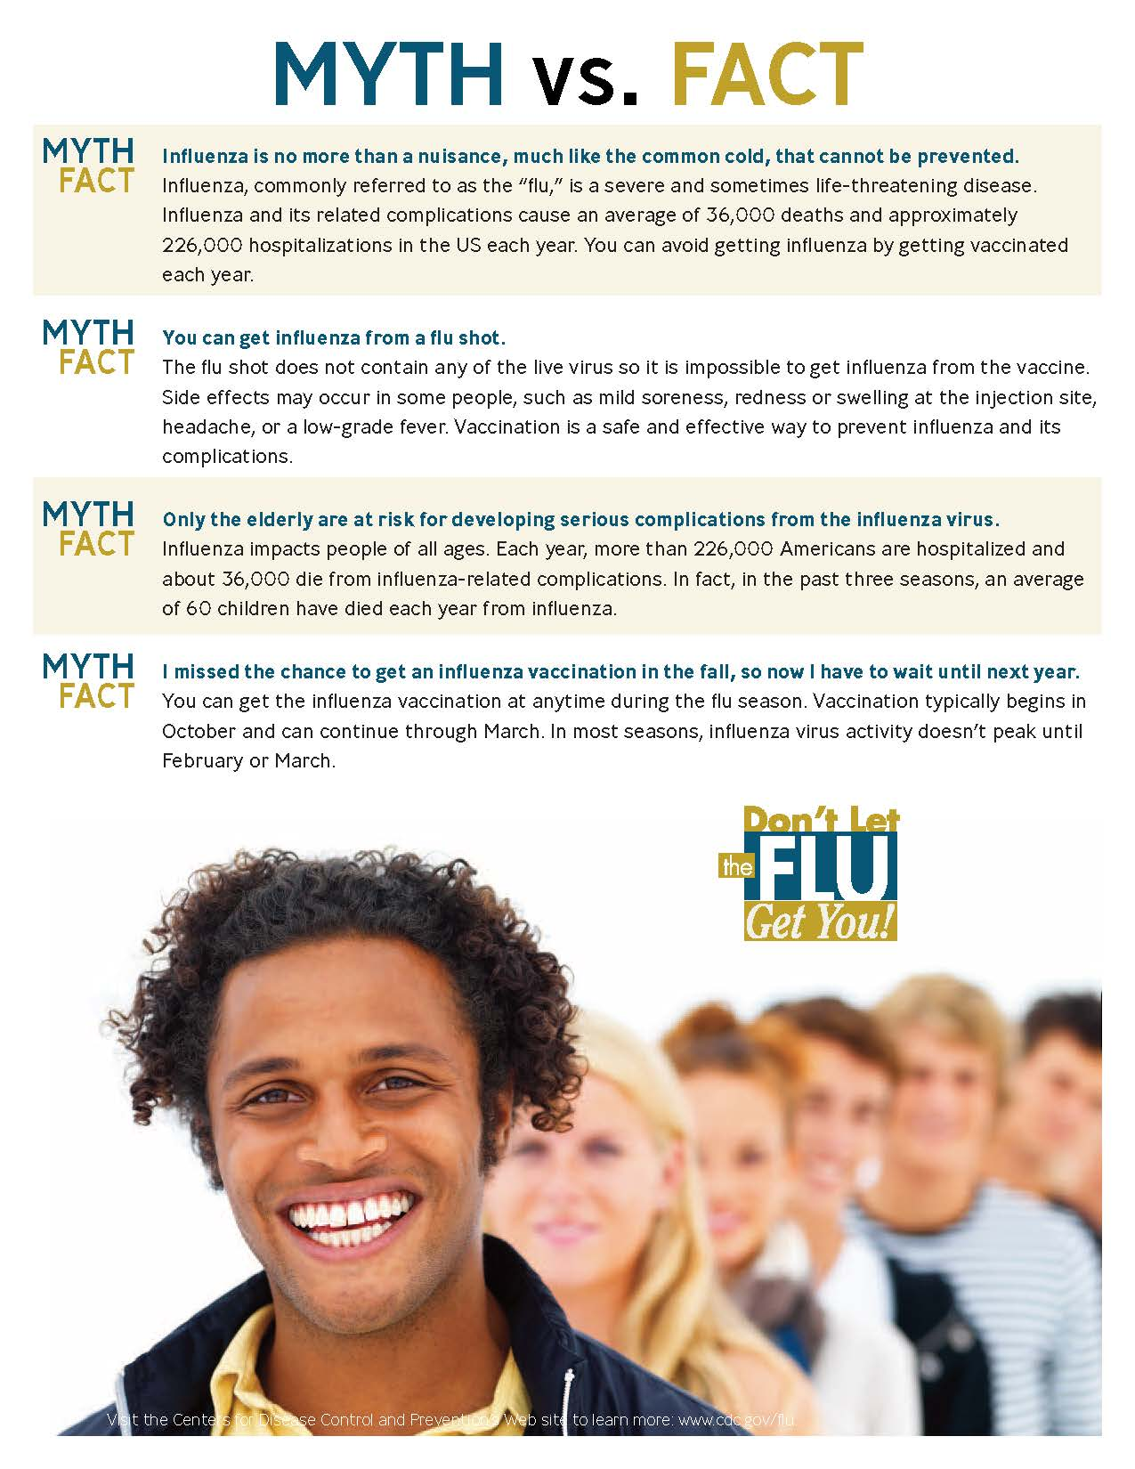

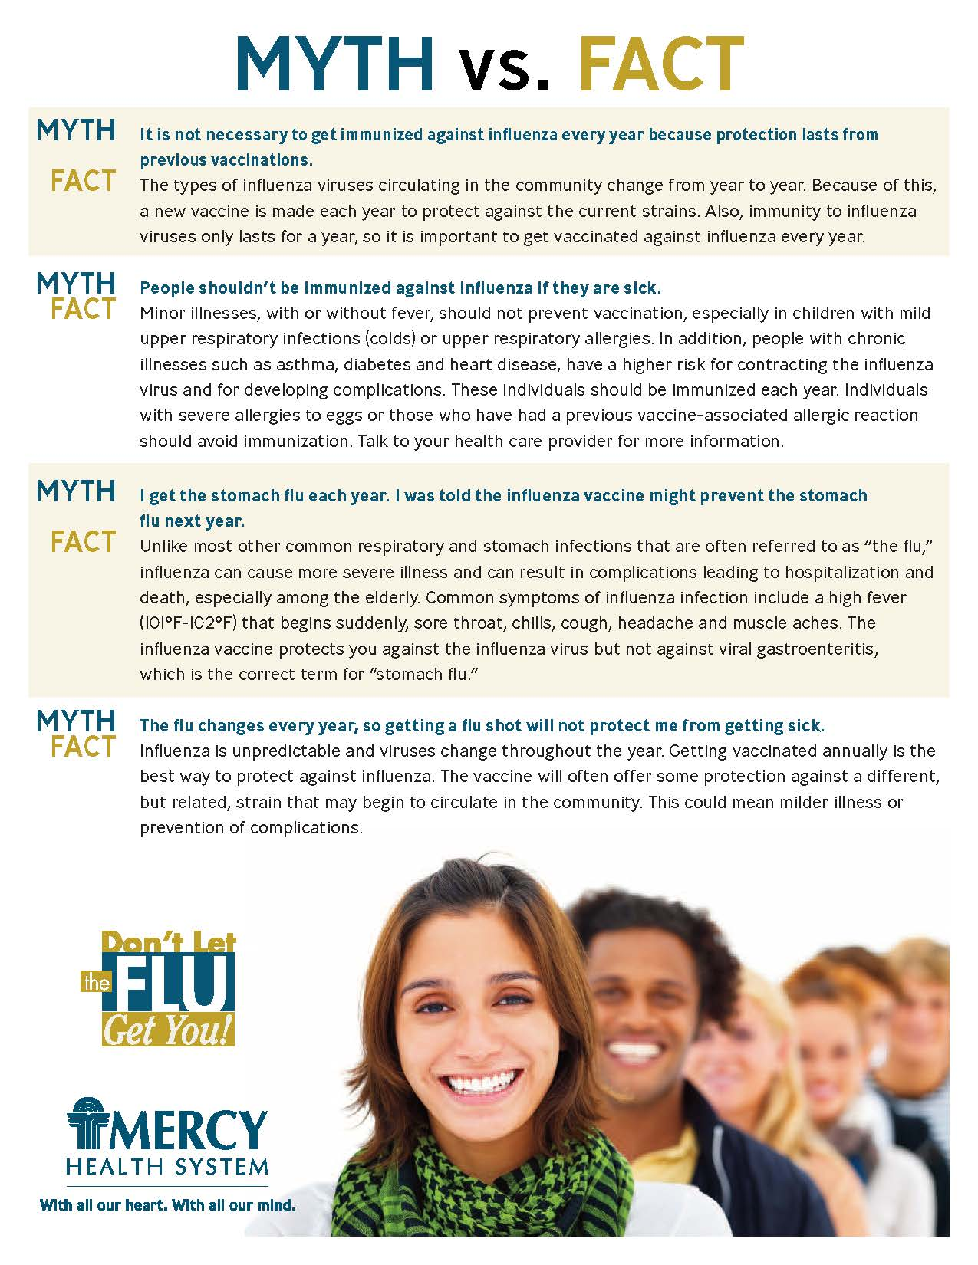

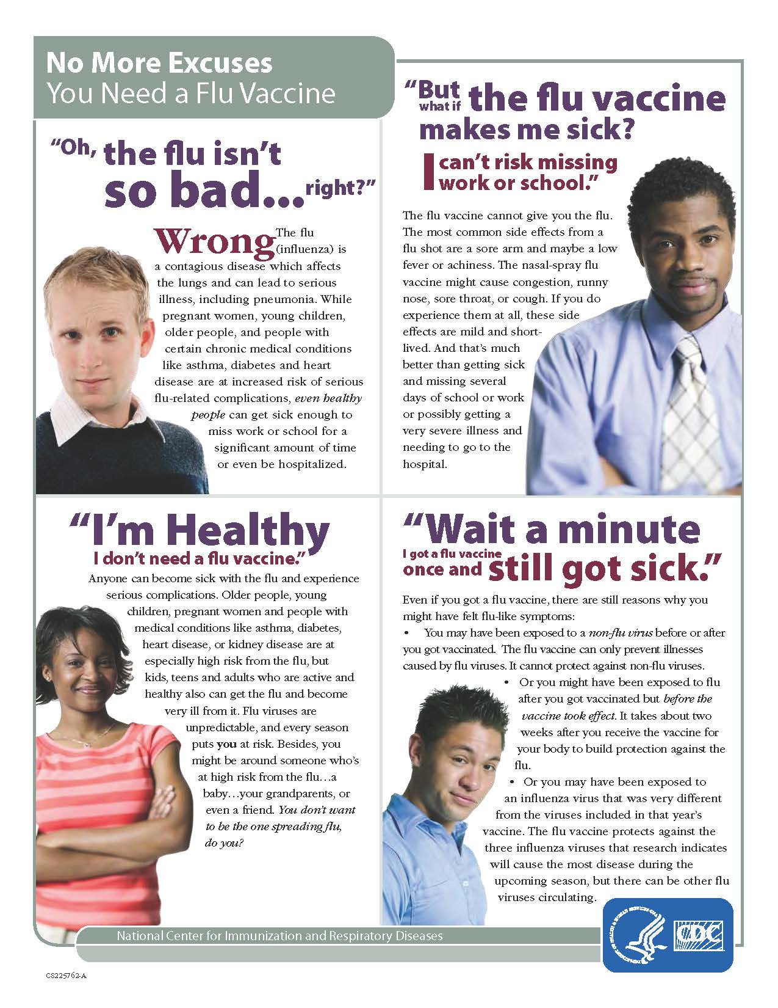

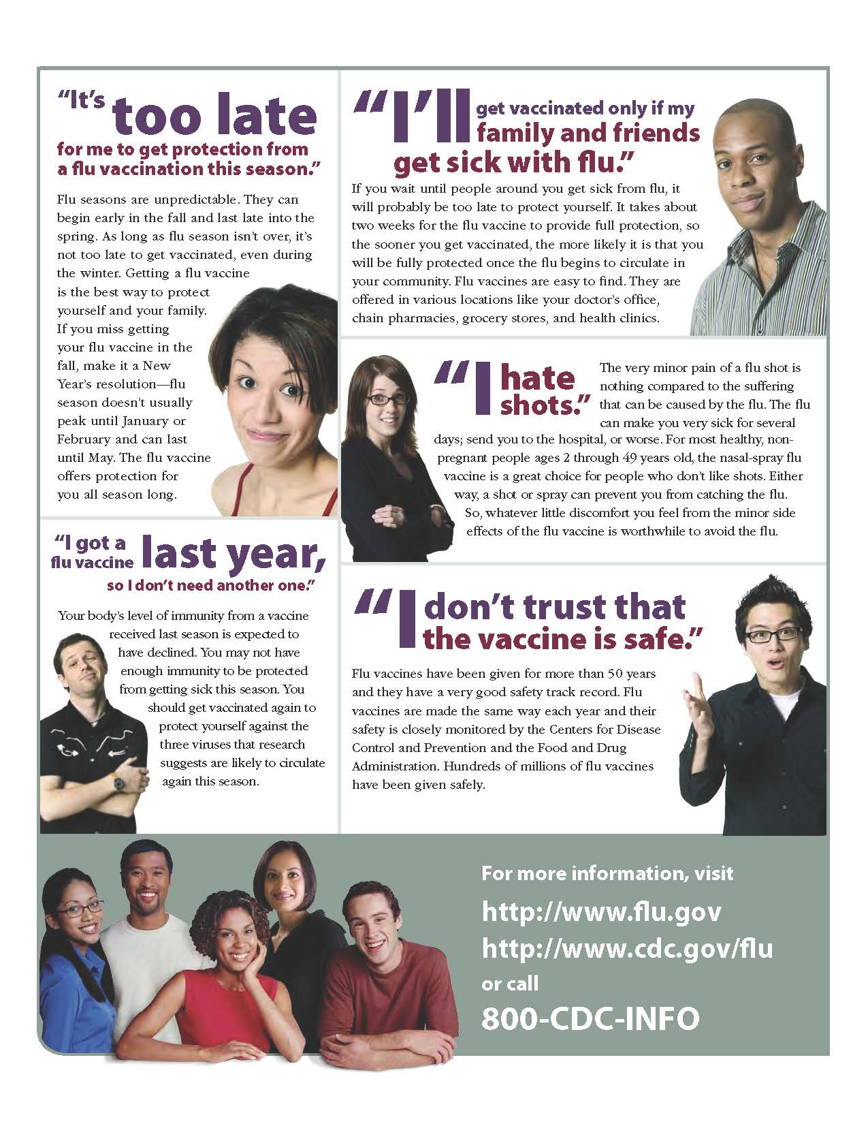

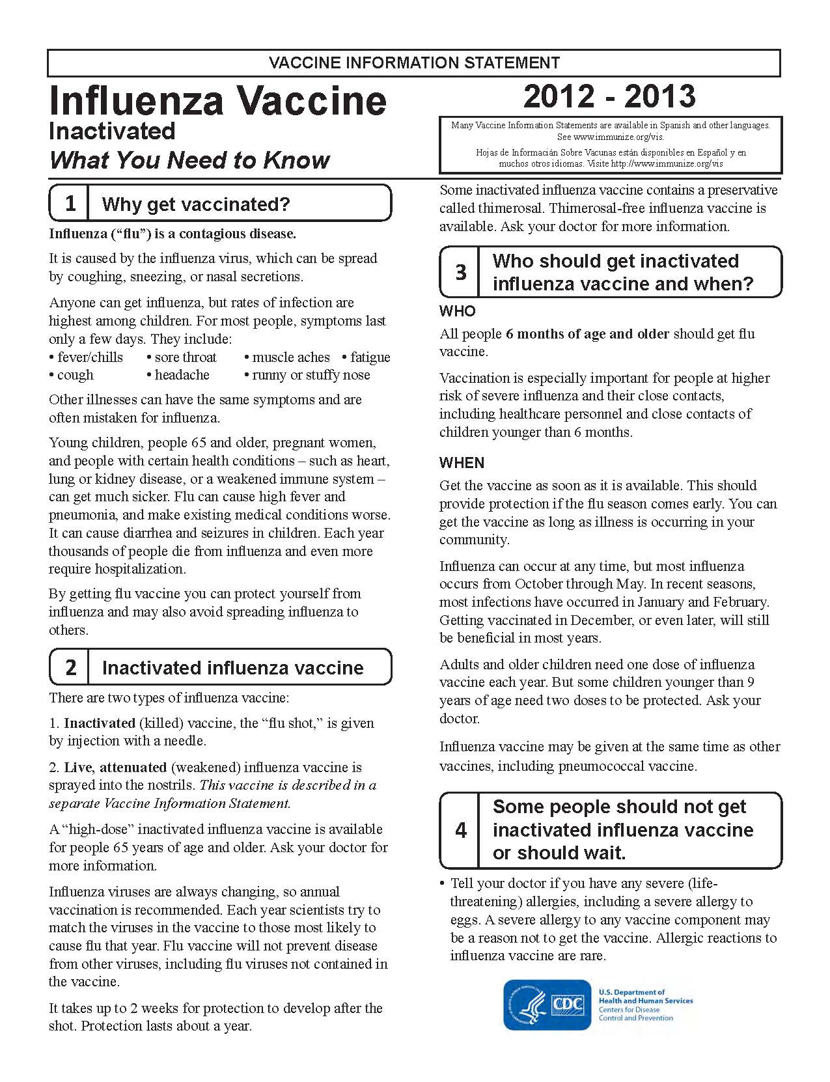
SAMPLE
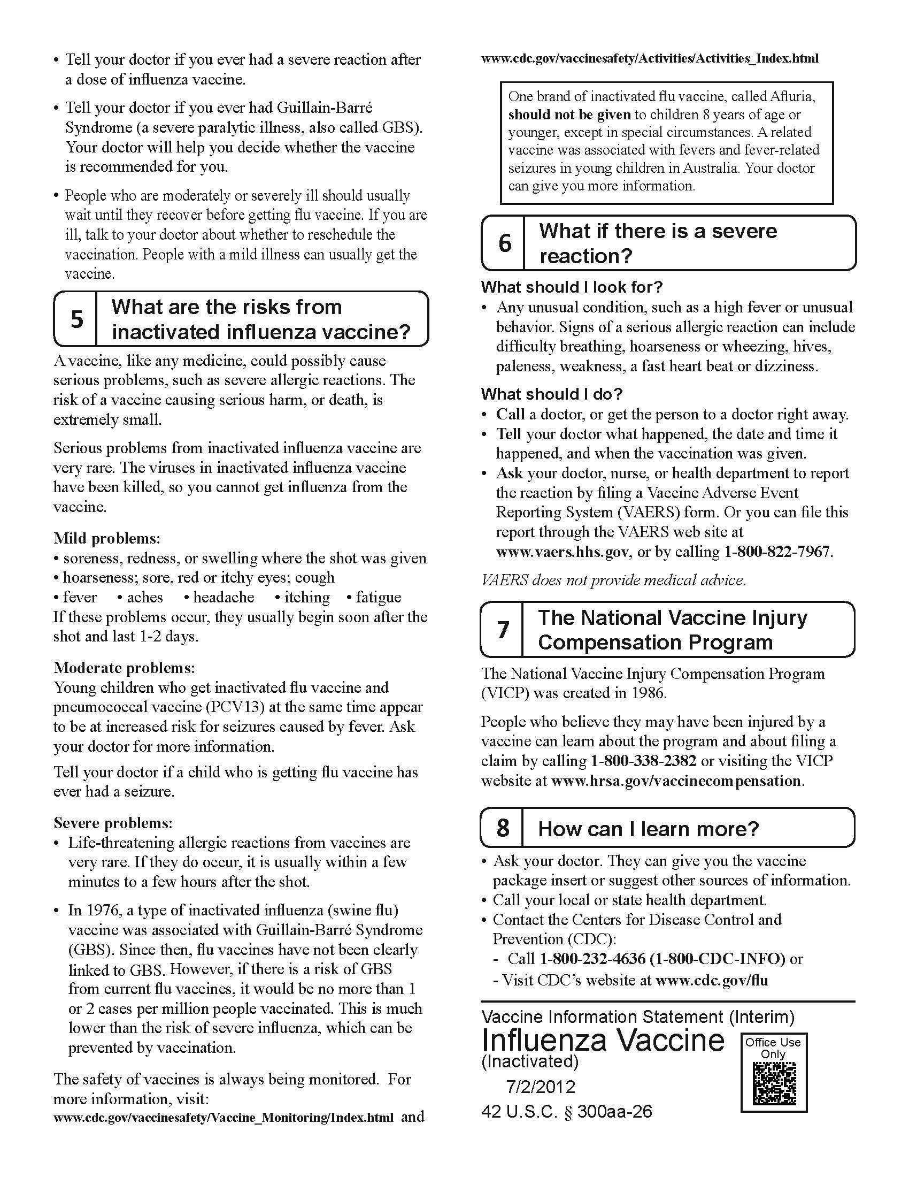


FOR IMMEDIATE RELEASE:

August 1, 2012

Affinity, ThedaCare team up against the Flu

Health Care Systems Ask Employees, Doctors to Get Influenza Vaccine
or Wear Masks to Protect Patients

Affinity Health System and ThedaCare are teaming up to help prevent the spread of influenza and upper respiratory diseases in the community.

Both health systems are requiring their employees, volunteers and students to be immunized against influenza. If employees cannot or decide not to receive the vaccine, they will need to wear a mask when interacting with patients, visitors and co-workers during the flu season. All employees showing symptoms of an upper respiratory infection with a fever will be encouraged to stay home. Those with symptoms without a fever will be asked to wear a mask regardless of their vaccination status.

“Our mission is to improve the health of our communities and one way to do that is to stop the spread of the flu to our patients. The best defense against the flu is to get the influenza vaccination,” said Greg Long, MD, chief medical officer for ThedaCare. “By receiving the vaccination, employees will not only protect their health, but also the health of patients and visitors.”

“This is the right thing to do. Our goal is to achieve a vaccination rate of 90 percent or higher to protect our patients, staff and the broader community,” said Mark Kerhberg, MD, chief medical officer for Affinity Health System. “We know that vaccination is one of the best ways of preventing the spread of influenza and keeping our community healthy.”

Getting an annual influenza vaccine is the No. 1 way people can stay healthy during the winter months. Complications of the flu include bacterial pneumonia, ear infections, sinus infections, dehydration, and can cause chronic medical conditions, such as congestive heart failure, asthma or diabetes to get worse. In addition, even though flu season is months away, leaders from both healthcare systems are reminding residents to plan to get vaccinated.

The Centers for Disease Control and Prevention recommends that everyone over the age of six months receive the vaccination each year. The flu virus is mainly spread by droplets made when people with the flu cough, sneeze or talk that land in a nearby person’s nose or mouth.

“By making our new policy public, we hope it demonstrates how important it is to receive the influenza vaccine and everyone will receive it once it becomes available,” Dr. Long said. “The flu is a serious illness causing people to miss school or work for several days. Some people especially the elderly and babies can be hit particularly hard by the illness.”

Information regarding Affinity and ThedaCare’s flu clinics will be released in the early fall.

Dr. Kerhberg said Affinity and ThedaCare met with their employees to gather as many viewpoints as possible and decided against making the vaccination mandatory, which has been done by some other healthcare organizations in the state. “We came up with the alternative of wearing a mask so employees can decide whether or not they want to receive the vaccination,” he said.

If patients have any questions about the new procedure, they can ask their healthcare provider.

Affinity Health System, a faith-based regional health care network, is operated by Ministry Health Care. Affinity Health System is the Fox Valley’s second-largest employer, according to the Fox Cities Chamber of Commerce & Industry, and has been nationally listed for two years in a row among the top 50 health systems for quality and efficiency (Thomson Reuters, Modern Healthcare; 2009, 2010). For nine consecutive years, Affinity Health System has been named to the SDI Health (formerly Verispan) Integrated Health Network Top 100, an annual assessment of the 100 most highly integrated health care networks in the nation – Affinity ranks no. 81 in the 2011 report. Both St. Elizabeth Hospital in Appleton and Mercy Medical Center in Oshkosh rank among the top 1 percent of hospitals nationwide in terms of quality and efficiency, as determined by the 2007 Premier | CareScience Select practice National Quality Award. Network Health Plan has achieved Excellent accreditation status from the National Committee for Quality Assurance (NCQA), the highest possible level. It has been nationally ranked in the Top 50 Health Insurance Plans for five consecutive years in the U.S. News and World Report/NCQA Best Health Plans in America listing. Members of Affinity include Mercy Medical Center and Mercy Health Foundation, Oshkosh; St. Elizabeth Hospital and the St. Elizabeth Hospital Foundation, Appleton; Affinity Medical Group, a regional network of 26 family practice and specialty clinics – 23 of which are transforming into medical home models – in 14 communities; Calumet Medical Center, Chilton; Network Health Plan, Menasha; and Affinity Occupational Health.

ThedaCare™ is a community health system consisting of five hospitals: Appleton Medical Center, Theda Clark Medical Center, New London Family Medical Center, Shawano Medical Center, and Riverside Medical Center in Waupaca. ThedaCare also includes ThedaCare Physicians, ThedaCare Behavioral Health, and ThedaCare at Home. ThedaCare is the largest employer in Northeast Wisconsin with more than 6,175 employees. Follow us on Facebook and Twitter.

For more information, media may contact Megan Wilcox, APR, at megan.wilcox@thedacare.org at ThedaCare or (920) 830-5847 or Maria Nelson at maria@redshoespr.com or (920) 720-1752 for Affinity.

###



323 South 18th Avenue │ Sturgeon Bay, WI 54235 │ 920.746.3712 │ ministryhealth.org

For more information, contact:
Kevin Grohskopf, Chief Business Development Officer
kevin.grohskopf@ministryhealth.org
920.746.3712

As Flu Virus Hits Early, Providers Encourage Vaccination

Sturgeon Bay, WI – January 17, 2013: With many states reporting an early start to the flu season, Wisconsin is no exception. “We started to see a significant increase in flu cases in early January,” reports Julie Pinney, RN, who is the Infection Prevention Specialist at Ministry Door County Medical Center (MDCMC).

Influenza symptoms include fever, body aches and headache, extreme fatigue, and cough. “The symptoms can be similar to a cold or other viruses, but if it is influenza, symptoms are more extreme,” says Pinney.

Ministry staff report that they have a good supply of the flu vaccine available, and more shipments on the way. Pinney encourages everyone who is eligible to receive a flu shot. “No, it’s absolutely not too late,” she urges.

For those who believe that the flu vaccine might make them sick, Pinney states plainly, “That’s a myth. The flu shot contains an attenuated, or dead, flu virus which cannot cause the flu. True, at times there are some side effects of body aches or headache. Those are caused by the patient’s body making antibodies.”

Mary Templin, Nurse Practitioner in MDCMC’s Occupational Health and Wellness department, has been working with schools and other workplaces in the community to immunize people and educate them about prevention. “The flu virus is transmitted through droplets which spread by coughing, talking, or sneezing. We encourage anyone suffering from the flu or a flu-like virus to stay home from work and refrain from being in public until 24-48 hours after their fever has subsided.” Providers also recommend regular hand washing, wiping grocery carts or other shared items in public with antibacterial wipes, and avoiding touching mouth, nose and eyes.

Those who are most vulnerable to the flu are very young children, the elderly, pregnant women, and patients with chronic health conditions or immunity problems. “We encourage these patients, or anyone with very severe symptoms, to see a provider,” says Templin.

This year’s flu vaccine includes prevention for Influenza A and B, as well as H1N1. “We’ve seen confirmed cases of both the A and B flu strains here in Door County,” says Julie Pinney. H1N1 has not been reported in the area this flu season.

Ministry Door County Medical Center is practicing what they preach- this year they made the flu shot mandatory for all health care workers. “If an employee declined, they are required to wear a mask while working,” says Pinney. And Ministry staff is working hard to see that the community knows that the best bet for prevention is getting a flu shot. “We’re trying to immunize as many people as we can,” says Mary Templin.

Sidebar:
Ministry North Shore Medical Clinic – Sturgeon Bay will be holding a Flu Clinic on Friday, February 8 from 8:30 am to 3:30 pm, open to all ages 5 and above. No appointment is necessary. We will bill your insurance or there is a cash fee of $26.

# # #

Talking Points

Spokespeople or person:
- Designate your spokespersons. A physician, epidemiologist, nurse or infection preventionist/quality professional are credible spokespersons on this topic.

Talking Points:
- An annual flu shot protects our patients and the community.
  - Caregivers interact with patients with compromised immune systems
  - Flu is deadly, especially coupled with another illness
  - As many as 49,000 people in the U.S. die from the flu annually. (CDC numbers)
  - People are contagious before symptoms arise
- (Organization/Coalition) believes that all health care entities should follow our lead.
  - This practice is becoming more common in health care settings.
  - It is in the best interest for our patients that each caregiver they see will not infect them with most kinds of flu.
- The flu vaccine is safe
  - The vaccine is made from dead virus which cannot infect a person
  - Decades of data have proven the safety of the vaccine
  - No vaccine is 100% effective in preventing any illness. And while the flu vaccine is a good match for what is circulating in the community, there is still a small chance that someone who receives the flu shot will still develop the flu. Data shows that these individuals have a greatly reduced risk of needing hospitalization and are sick fewer days than those that get the flu are have not been immunized.
- Exemptions
  - Caregivers who are allergic to the vaccine are exempt (or other medical reasons)
  - Other reasons, such as religion, will be considered on a case by case basis
- The vaccine
  - Include information about the “recipe,” for example, flu strains included, whether it is similar to the year before
- Other organizations advocating for this policy or following these guidelines include:
  - American Academy of Pediatrics
  - American College of Physicians
  - American Hospital Association
  - American Medical Association
  - Association of Professionals in Infection Control and Epidemiology (APIC)
  - Immunization Action Coalition
  - Infectious Disease Society of America
  - National Patient Safety Foundation
  - Society for Healthcare Epidemiology of America
  - More: http://www.immunize.org/honor-roll/

Wisconsin State Journal article

UW Health requires flu shots
November 12, 2012 • DAVID WAHLBERG | Wisconsin State Journal | dwahlberg@madison.com | 608-252-6125

THE WISCONSIN FLU STRAIN

Each year, the flu shot contains three strains to protect against the flu viruses most likely to circulate that year. This year’s strains: California, Victoria and Wisconsin. The strains are named for the places where the flu samples were first isolated.

The Wisconsin strain is from a specimen collected last year, said Pete Shult, communicable disease director at the Wisconsin State Laboratory of Hygiene. It’s representative of a type B flu strain likely to predominate this season, Shult said.

The last time a Wisconsin strain was in the vaccine was the 2006-07 and 2007-08 flu seasons.
UW Health is requiring employees to get flu shots this year, as more health care organizations say mandates ensure workers and patients are protected from infection.

“It makes sense to do whatever we can to implement the one measure we know will reduce hospital-acquired influenza,” said Dr. Nasia Safdar, head of infection control for UW Hospital.

SEIU Healthcare Wisconsin, which represents UW Hospital nurses and therapists, is asking UW Health to consider an exemption for personal beliefs. The policy allows medical and religious exemptions.

“We support flu shots, but we don’t think they should be mandatory,” said union treasurer Ann Louise Tetreault.

Stoughton Hospital is also requiring worker flu shots this year. St. Mary’s Hospital started the requirement last year, when 26 percent of hospitals and 12 percent of nursing homes in Wisconsin had mandates, according to the state Department of Health Services.

Another 69 percent of hospitals and 75 percent of nursing homes made workers sign waivers if they didn’t get vaccinated.

Dean Health System and Group Health Cooperative of South Central Wisconsin don’t require worker flu shots. Meriter Health Services doesn’t have a mandate but will consider one next year, spokeswoman Mary Reinke said.

That’s also the case at Capitol Lakes Health Center, a nursing home in Madison, said administrator Kristi Vater. Other nursing homes, such as Oakwood Village, which has two campuses in Madison, aren’t considering a mandate.

John Sauer, president of Leading Age Wisconsin, which represents nonprofit nursing homes, said he expects most nursing homes will eventually have mandates. “An outbreak of flu can really put residents at risk,” Sauer said.

Flu season generally runs from October to May, with peak activity in January or February. Little activity has been reported this fall in Wisconsin or around the country.

The Centers for Disease Control and Prevention says nearly everyone 6 months and older should get an annual flu shot, which changes each year to match the three strains most likely to circulate. People with egg allergies and those who have had severe reactions to flu shots should talk to their doctors, the CDC says.

Despite the universal recommendation, only 42 percent of Americans got flu shots last year, according to the CDC. In Wisconsin, it was 41 percent.

Nearly 67 percent of health care workers were vaccinated last year, including 86 percent of doctors. There’s a push to get those rates above 95 percent.

At UW Hospital, 85 percent of workers were immunized last year. Figures weren’t available for other parts of UW Health.

The mandate should boost rates to 95 percent to 98 percent, Safdar said.

UW Health employees will be put on unpaid leave if they don’t get vaccinated by Dec. 1 or submit a religious waiver or medical waiver signed by a doctor. Workers who don’t comply after another 45 days could be fired.

The SEIU union encourages workers to get shots, stay home when they’re ill and frequently wash their hands. The mandate goes too far, the union says.

But Safdar said vaccinating more employees means protecting more patients from infections.
“It’s a patient safety issue,” she said. “Why be satisfied with anything less than the ideal?”
Read more: http://host.madison.com/news/local/health_med_fit/uw-health-requires-flu-shots/article_e85fde19-082a-5ea3-9aa1-7e91f6c36d86.html#ixzz2LMlZB7hI

XXX

Milwaukee Journal Sentinel article

Aurora boosts flu vaccination rate with new policy

By Mark Johnson of the Journal Sentinel
May 9, 2012

Aurora Health Care made getting an annual influenza vaccination a condition of employment for its more than 30,000 workers in eastern Wisconsin and northern Illinois with swift results.

In 2010, 71% of the health care chain's employees got the vaccination. In the 2010-2011 flu season, the percentage rose to 97.7%. Employees who did not receive the vaccination had to receive an exemption for an approved medical or religious reason.

Aurora officials could not say yet whether the improved vaccination rate translated into improved health results.

"This year was a mild flu season, and it's hard to measure the immediate impact with just one season of data," said Bruce Van Cleave, executive vice president and chief medical officer for Aurora Health Care. "In three years we'll have enough data to measure a number of outcomes reliably.

"I'm glad we did this. It was the right thing to do for patients and employees."

[ORGANIZATION NAME AND LOGO]
Health Care Personnel Influenza Vaccination Policy
Frequently Asked Questions

(These are sample FAQs that should be modified by each organization to match your final policy)

Overview:
Q: Why is [ORGANIZATION NAME] making the influenza vaccine a condition of employment?
A: To ensure we are doing all we can to help our patients live well and to protect their health and safety, [ORGANIZATION NAME] requires all health care personnel receive the annual influenza vaccination as a condition of employment and maintenance of clinical privileges. Getting a vaccination is one of the most effective ways to help prevent unnecessary deaths and stem the spread of this preventable disease. We care about you, your family and patient safety, and want everyone to be protected.

Q: Who does the policy apply to?
A: The [INSERT NAME OF POLICY] applies to all [INSERT WHO POLICY APPLIES TO].

Q: By what date to I need to receive my influenza vaccine?
A: All health care personnel must be vaccinated by [INSERT DATE].

Q: Are there exemptions from the policy? If so what is the process?
A: Exemption forms are available [INSERT WHERE FORMS CAN BE OBTAINED]. The Medical Exemption form should be completed and certified by your personal health care provider, while the Religious Exemption form can be completed by the requestor or clergy member. Completed forms should be submitted to [INSERT WHERE TO SUBMIT TO] by [INSERT DATE]. Personnel will be notified by [INSERT DATE] if their exemption is approved.

Q: What will happen if I refuse to be vaccinated?
A: If you choose not to be vaccinated you will not be allowed to work or practice after [INSERT DATE] and we will consider you to be voluntarily terminating your employment or relationship with [ORGANIZATION NAME].

Reasons for the Policy:
Q: I do not have direct patient contact. Why must I be vaccinated?
A: It is too difficult to determine where to draw the line between those personnel that have contact with patients and those who do not. Almost everyone comes into contact with someone, who comes into contact with someone who has contact with patients.

Q: Couldn’t we just wear masks instead of being vaccinated?
A: The use of paper masks on a prolonged basis has not been shown to be an effective strategy to prevent the spread of influenza. It would be very difficult to manage and enforce, leaving patients vulnerable to those who were supposed to wear masks and did not. Also, prolonged use of masks can make a patient’s experience seem more scary and urgent than necessary.

Q: Is the vaccine really safe for me to receive?
A: The same process to produce and test the vaccine has been used for decades, and is repeated year after year. There is a small risk associated with any vaccination. We need to consider the risk/benefit and determine if the minimal risk outweighs the risk of doing nothing and potentially causing personal illness and possibly life-threatening illness to our patients. The degree of risk is similar to that of TB testing and rubella vaccinations already required for many health care personnel. Other systems that have implemented similar policies have not seen an increase in negative vaccine related incidents.

Vaccine Safety and Effectiveness:
Q: Is the vaccine really effective for this year’s influenza strains?
A: Scientists have concluded there are only two to three strains circulating in the world at any one time. Each year, in the February/March timeframe, the composition of the vaccine is determined based on the previous influenza season and what is happening in the Southern hemisphere, since history shows that the virus begins there and then moves north.

Q: Can’t the influenza vaccine actually give me the flu?
A: No! Neither the injectable (inactivated) vaccine nor the live attenuated (nasal spray) vaccine can cause influenza. The injectable influenza vaccine contains only killed viruses and cannot cause influenza disease while the nasal spray vaccine contains live attenuated (weakened) viruses that at worst can only produce mild symptoms similar to a cold. Any vaccination can be associated with short-term fever of less than 101 degrees and aches at the injection site lasting less than 24 hours. These nuisance type symptoms are likely caused by your body’s response to a foreign presence. Any experience of the flu is coincidence and most likely the result of whatever is circulating during the season when you are vaccinated because the vaccine is not effective immediately.

Qualifying for an Exemption:
Q: What medical conditions will be accepted for a medical exemption?
A: Per the policy, documentation of: [MATCH LIST TO POLICY]
- Documented serious adverse reaction to previous influenza vaccine
- Significant allergy to eggs (anaphylactic or systemic reaction)
- History of Guillain-Barré Syndrome

Q: How do I qualify for a religious exemption?
A: A religious conviction exemption from influenza vaccination will ONLY be granted if a vaccination violates the tenets of a health care personnel’s religious beliefs. Your supporting statement as well as any supporting statements from your religious leader (with contact information for follow-up) will assist us in an initial evaluation of your religious conviction exemption request. We will review requests on a case-by-case basis.

Q: Are there other reasons besides medical and religious that would qualify?
A: No, per policy only medical and religious reasons will qualify for an exemption.

Exemption Process:
Q: What if I have a medical condition or religious conviction and cannot receive the influenza vaccine?
A: You may obtain the appropriate exemption request form from [INSERT WHERE FORM CAN BE OBTAINED]. The form must be returned to [INSERT WHERE TO RETURN FORM TO] by [INSERT DATE]. A team will review all requests and you will be notified by [INSERT DATE] as to whether or not your request has been approved. If not approved, you must provide documentation or be vaccinated by [INSERT DATE].

Q: What if I do not have a doctor who can fill out my medical exemption request form?
A: The form requires an appropriate signature to certify the information submitted.

Q: Can an employee health nurse [INSERT NAME OF EMPLOYEE HEALTH] sign the medical exemption form?
A: No, this form must be signed by a medical professional that provides your routine medical care.

Q: What if I miss the [INSERT DEADLINE DATE] deadline to apply for an exemption?
A: Unless you have developed a new condition since the [INSERT DATE] deadline, forms will not be accepted after [INSERT DEADLINE DATE].

Q: When will I know if my exemption request qualifies?
A: The review team will meet regularly to review any exemption forms submitted. As soon as a form is reviewed, you will be notified of the result via [INSERT HOW NOTIFICATION WILL OCCUR]. All decisions will be sent to health care personnel by [INSERT DATE].

Q: Will my manager know about my request for an exemption?
A: Managers will have access to information about their staff that indicates who from their team has been vaccinated, who has submitted a request for an exemption and the status of each exemption request. The manager will not have access to the medical nature of the request that is protected by HIPAA.

Q: What if my request is denied?
A: You will have until [INSERT DATE] to receive the vaccination.

Q: Is there an appeal process?
A: Unless there is new information that had not previously been reviewed, there is no appeal process. Personnel should talk to [INSERT NAME OF EMPLOYEE HEALTH DEPARTMENT] with any questions about their particular situation.

Vaccination Deadline:
Q: By what date must I be vaccinated?
A: You will have until [INSERT DATE] to receive the vaccination.

Q: What if I receive a flu vaccine somewhere else?
A: Vaccinations given through Employee Health [OR NAME OF WHO WILL GIVE VACCINATIONS] will automatically be tracked. If you receive the vaccination elsewhere, proper documentation, including vaccine lot number and the signature of the person administering the vaccine, must be submitted to [INSERT WHERE TO SUBMIT DOCUMENTATION TO] by [INSERT DEADLINE DATE]. [INCLUDE MENTION OF A FORM IF ONE IS REQUIRED].

Q: What if I am on a leave of absence and will not return until after [INSERT VACCINATION DEADLINE]?
A: All personnel who are on a leave of absence during the vaccination period will be required to receive an influenza vaccination before they will be allowed to return to work or submit a form applying for an exemption. The vaccine may be received from Employee Health prior to the return to work or documentation of receiving the vaccine elsewhere must be submitted to Employee Health prior to the return to work.

Q: What if there is a shortage of vaccine?
A: In the event of a shortage of vaccines, personnel will receive additional instruction as to the distribution of the vaccine to ensure our most vulnerable patients are protected.

Q: If I refuse to vaccinated, will I be terminated?
A: If you choose not to be vaccinated by [INSERT DATE], we will consider you to be voluntarily terminating your employment or relationship with [ORGANIZATION NAME].

Who is Included:
Q: Are physicians included in this policy?
A: Yes, physicians and all health care professionals who have clinical privileges with [ORGANIZATION NAME] are covered by this policy.

Q: Who else is covered by this policy?
A: [LIST THOSE COVERED BY THE POLICY]

Q: What about new hires?
A: This will be integrated into the new hire process just like any other pre-employment requirement.

For More Information:
Q: Where can I go for more information about the influenza vaccine?
A: [INSERT WHERE ADDITIONAL INFORMATION CAN BE OBTAINED]

Q: Who do I contact if I have questions about the policy?
A: [INSERT WHERE QUESTIONS SHOULD BE DIRECTED TO]

Promising Practices from Wisconsin Hospitals and Health Systems
All Wisconsin hospitals encourage their health care personnel to receive influenza vaccinations; however, the movement to require vaccination is growing. A number of hospitals and health systems in Wisconsin have already implemented mandatory vaccination programs. Several of these organizations have agreed to share their policies and forms, to help the entire Wisconsin health care community move toward mandatory influenza vaccinations for health care personnel.

All of the organizations positioned their programs as patient and employee safety imperatives. In each of the programs, support from senior leadership and physician leaders was critical to their success. Many professional champions played key roles; however, chief medical and chief nursing officers, infection control and occupational health specialists, human resource directors, as well as marketing and legal staff, are recognized as integral to all aspects of implementation.

The following are additional themes common among all organizations outlined here:

Common organizational elements:
- Establish seasonal influenza vaccination as a condition of employment and maintenance of medical staff privileges that impacts all health care workers, including employees, members of the medical staff, volunteers, students, and vendors.
- Establish a clear and consistent process for granting medical and religious exemptions. The number of exemptions granted is very low. Almost all employees who are denied an exemption will choose to receive the vaccine.
- Early work and good communication with applicable unions will help secure their support for organized labor units.
- Establish a clear, fair and consistent process for dealing with health care personnel who choose not to be immunized. Very few workers end up being terminated.
- Establish clear channels of communication with all affected, starting with managers. Ensure the all management team members understand their role in supporting and implementing the new policy.
Key Strategies:
- Define and announce target populations early.
- Create a robust tracking system, with the ability to generate interim reports for local manager follow-up.
- Develop a plan for interruption of the vaccine supply.
- Develop a detailed exemption review process. If possible, do not leave this responsibility to a single person.
- Develop policies around verifying external employee vaccination administration.
The following organizations provided assistance with creating this toolkit including expertise and copies of policies and forms. See Appendix B for examples of their policies.
- Agnesian HealthCare
- Aurora Health System
- Holy Family Memorial Hospital
- Marshfield Clinic
- Mercy Health System
- Ministry Health Care
- Monroe Clinic
- ProHealth
- St. Clare Hospital
- UW Health
- Wisconsin Healthcare Public Relations and Marketing Society

Appendix A

Guidelines for Reporting to CDC-NHSN

Overview:
- Reporting of Health Care Personnel Vaccination rates is an annual CMS requirement for all Prospective Payment hospitals. It is also a requirement for all acute care hospitals affected by the Wisconsin Medicaid hospital pay-for-performance program.
- Reporting must be done through the CDC - National Healthcare Safety Network (NHSN) module. Assistance with reporting to NHSN can be obtained from the Department of Public Health.
- Annual reporting must be completed by May 15 of each year.

The following table contains NHSN’s definition of Health Care Personnel

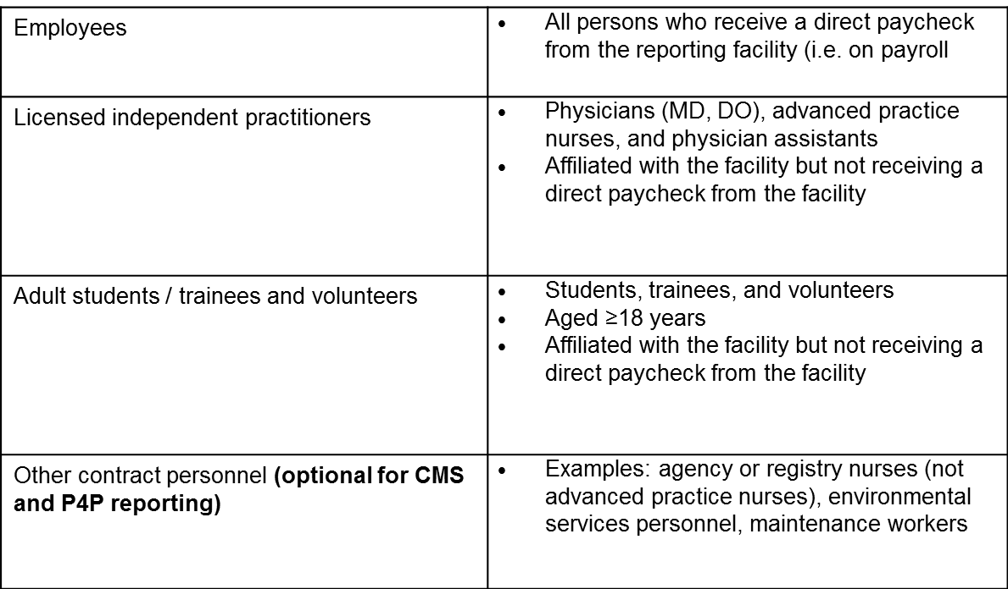

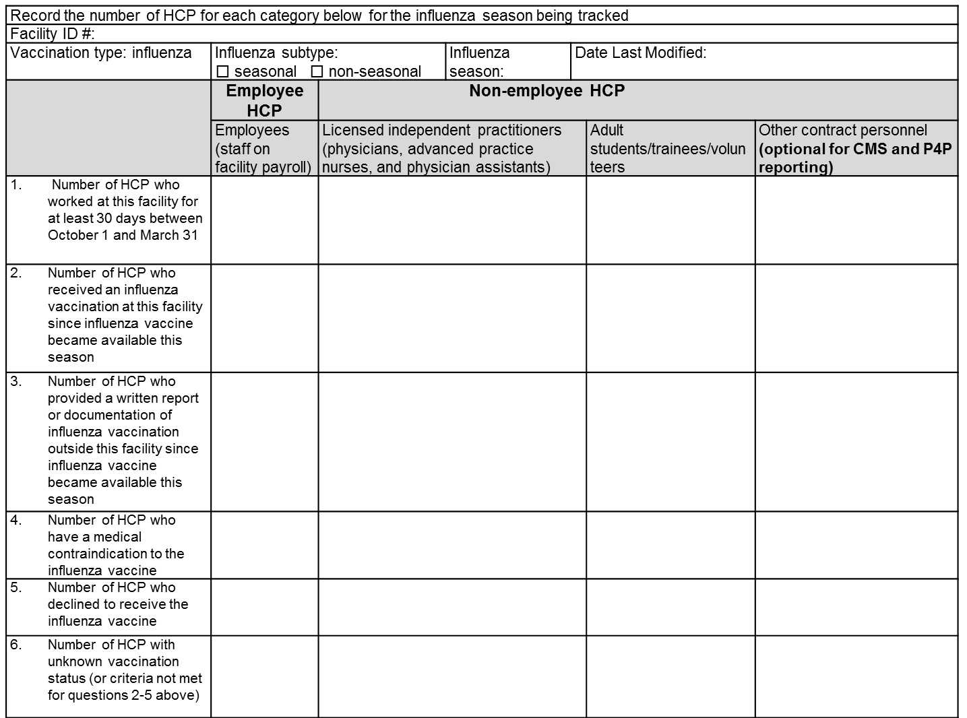
NHSN

Appendix B
Sample Policies

